ASSIGNMENT

OF

BCA-171

(C PROGRAMMING LANGUAGE)

BACHELOR OF COMPUTER APPLICATION

Academic Session:2021-22(ODD)Batch-2021-24



Submitted to: Submitted by:

Ms. Ambooj Yadav Name: Devina Dugar

Assistant Professor Enrolment no. :1324

Programme: BCA

Semester: 1st

Shift:2nd

Division: A



***INDEX***

|  |  |
| --- | --- |
| 1. | WAP to print hello in c programming language. |
| 2. | WAP to build a resume. |
| 3 | WAP to display the sum of three variables. |
| 4. | WAP to display range of datatype using built-in constant. |
| 5. | WAP to display the ascii value of a character. |
| 6. | WAP to print char type variable. |
| 7. | Write a menu driven program to construct a calculator for following arithmetic operations |
| 8. | WAP to calculate the percentage and average of five subjects. |
| 9. | WAP to check number are equal or not using conditional operator. |
| 10. | WAP to print max of three numbers using conditional operator. |
| 11. | WAP to find area and perimeter of a circle. |
| 12. | WAP to calculate the area of rectangle. |
| 13. | WAP to demonstrate “size of” operator. |
| 14. | WAP to swap two variables using third variable. |
| 15. | WAP to swap two variables without using third variable. |
| 16. | WAP to check the human is eligible for vote or not. Take the input from the user. |
| 17. | WAP to check whether the number entered is even or odd. |
| 18. | WAP to check number is greater than 100 and less than 1000. |
| 19. | WAP to find the greatest and maximum of three numbers. |
| 20. | WAP to demonstrate post increment and pre increment and pre decrement. |
| 21. | WAP to calculate the square of those numbers whose least significant digit is 5. |
| 22. | WAP to calculate salary of a medical sales representative based on the sales. Bonus and incentives to be offered to him will be based on total sales if the sales exceed or equal to rs.1,00,000. Follow the particulars of table1 otherwise table2.  TABLE-1 TABLE-2   * Basic-3,000 Basic - 3,000 * HRA-20% of basic HRA-20% of basic * DA-110%of basic DA-110% of basic * Convenyance-500 Conveyance - 500 * Incentive-10%of sales Incentive-5%of sales * Bonus-500 Bonus-200 |
| 23. | WAP to build a calculator using switch keyword. |
| 24. | WAP to show whether the number is even or odd using goto keyword. |
| 25. | WAP to convert temperature from ◦c to ◦f by taking input from the user. |
| 26. | Write a menu driven program to construct a calculator.  * |
| 27. | WAP to calculate SI and CI input taken by user. |
| 28. | WAP to print first five number starting from 1 together with their square. |
| 29. | WAP to print table of 2. |
| 30. | WAP a program to find the sum of following series. |
| 31. | WAP to find the perfect square from from 1 to 500. |
| 32. | WAP to print a reverse series 100 to 1. |
| 33. | WAP to print factorial of a given number. |
| 34. | WAP to print Fibonacci series till the nth pattern. |
| 35. | WAP to count the number of students having age less than 25 and weight less than 50kg. |
| 36. | WAP to print diamond pattern (taking number of rows as input from the user.) |
| 37. | WAP to reverse the number entered by the user. |
| 38. | WAP to print series from 1 to n using do-while loop. |
| 39. | WAP to calculate the square and sum of the digits of a series from 1 to n same as the question above. |
| 40. | WAP to demonstrate the use of break keyword. |
| 41. | WAP to check whether a number is a palindrome or not. |
| 42. | WAP to check whether a number is Armstrong or not. |
| 43. | WAP to print morning, evening and night using functions. (Without argument and without return value) |
| 44. | WAP to check whether the number is given is prime or not, using user define function (without argument or return type). |
| 45. | WAP to check whether the number is given is prime or not, using user define function (with argument &with return type). |
| 46. | WAP to calculate the square of numbers from 1-5 using a user defined function. (With argument & without return value) |
| 47. | WAP to calculate the average of three numbers using functions. (With argument & with return value) |
| 48. | WAP to calculate the average of three numbers using functions. (With argument & with return value) |
| 49. | WAP to describe the call by reference concept in functions by swapping two variables with the help of third variable. |
| 50. | WAP to skip a number in a series using continue. |
| 51. | WAP to display the following pattern n rows and rows taking the value of n from the user.  /*1  2 3  4 5 6  7 8 9 10  11 12 13 14 15*/ |
| 52. | WAP to print alphabetical pattern. |
| 53. | WAP to exchange the value of two variable by call by value of the function. |
| 54. | WAP to exchange the value of two variable by call by reference of the function. |
| 55. | WAP to print numbers and their sum up to five using recursion. |
| 56. | WAP using recursion to display sum of digits of a given number. |
| 57. | WAP to display element of two array in two separate columns at their corresponding element. Display the result of addition in third column. * |
| 58. | WAP to find min and max element of array. |
| 59. | WAP to find remainder and quotient of given dividend and divisor. |
| 60. | WAP to find largest number among three number using logics and operator. |
| 61. | WAP to print an array element and their address side by side. |
| 62. | WAP to print array elements and their address take array length input from user. |
| 63. | WAP to find given year is a leap or not using an array. |
| 64. | WAP to find the sum of odd and even numbers from an array take array length and elements input from user. |
| 65. | WAP to check the occurrences of a character in a string. |
| 66. | WAP to print an array row and column wise. |
| 67. | WAP to find transpose of a matrix using two-dimensional array. |
| 68. | WAP to print address of elements of an array using pointer.  G50 |
| 69. | WAP to print value of an array by index and by using pointer pointer. |
| 70. | WAP to store n elements in an array and print the elements using pointer. |
| 71. | WAP in c to find the largest element using dynamic memory allocation. |
| 72. | WAP to calculate the length of the string using pointer. |
| 73. | WAP to print a reverse string using pointer. |
| 74. | WAP to input elements in an array using dynamic memory allocation (use calloc). |
| 75. | WAP to read an array and print the sum of all elements using dynamic memory allocation. (Use malloc) |
| 76. | WAP to increase the size of allocated memory of a string using realloc. |
| 77. | WAP to print the sum of two numbers using extern function. |
|  |  |
|  |  |
|  |  |
|  |  |
|  |  |
|  |  |
|  |  |
|  |  |
|  |  |
|  |  |
|  |  |
|  |  |
|  |  |
|  |  |
|  |  |
|  |  |
|  |  |
|  |  |
|  |  |
|  |  |
|  |  |
|  |  |
|  |  |
|  |  |
|  |  |
|  |  |
|  |  |
|  |  |
|  |  |
|  |  |
|  |  |
|  |  |
|  |  |
|  |  |
|  |  |
|  |  |
|  |  |
|  |  |
|  |  |
|  |  |
|  |  |
|  |  |
|  |  |
|  |  |
|  |  |
|  |  |
|  |  |
|  |  |
|  |  |
|  |  |
|  |  |
|  |  |
|  |  |
|  |  |
|  |  |
|  |  |
|  |  |
|  |  |
|  |  |
|  |  |
|  |  |
|  |  |
|  |  |
|  |  |
|  |  |

1. WAP to print “Hello World” in C programming language.

Coding:

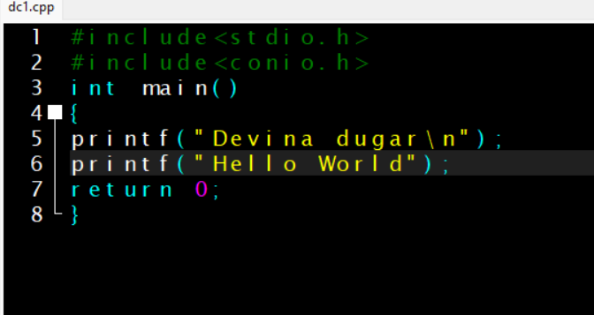

Output:

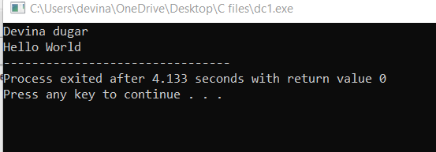

1. WAP to build a resume.

Coding:

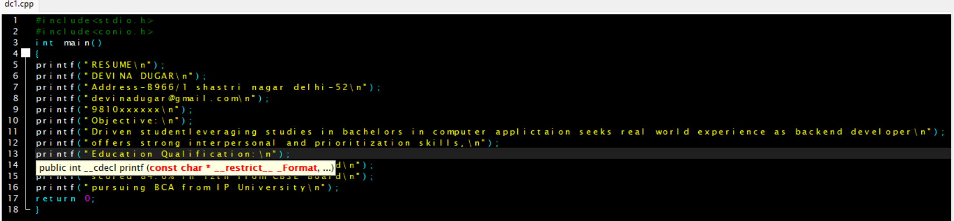

Output:

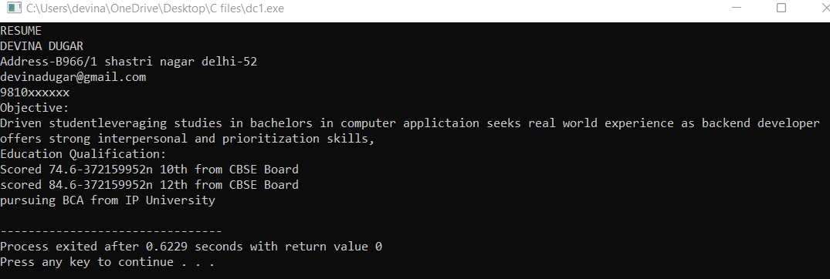

1. WAP to display the sum of three variables.

Coding:

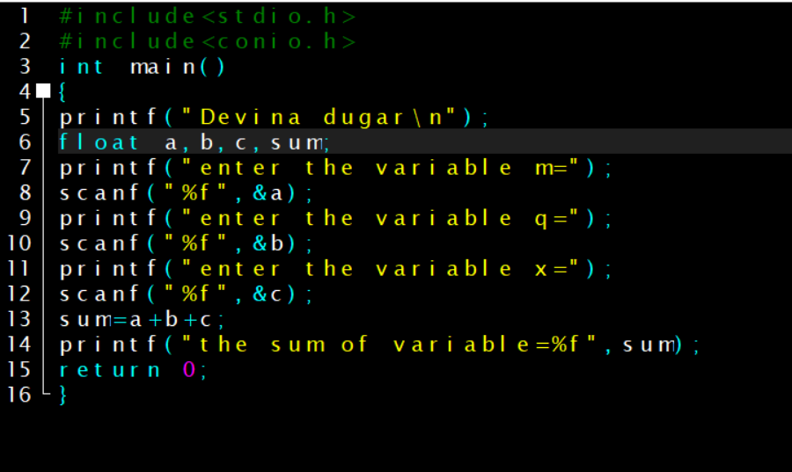

Output:

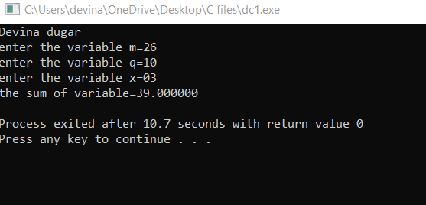

1. WAP to display range of datatype using built-in constant.

Coding:

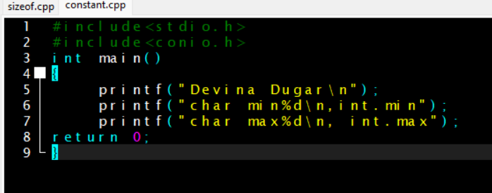

Output:

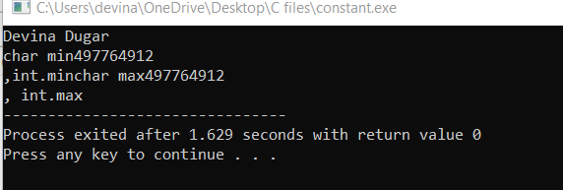

1. WAP to display the ascii value of a character.

Coding:

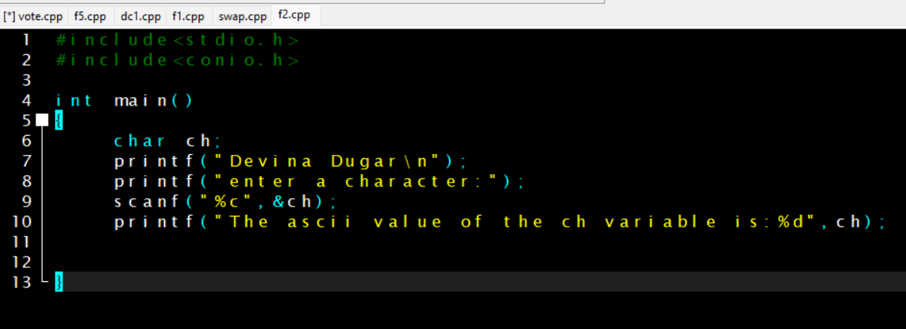

Output:

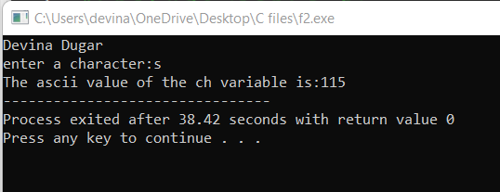

1. WAP to print char type variable.

Coding:

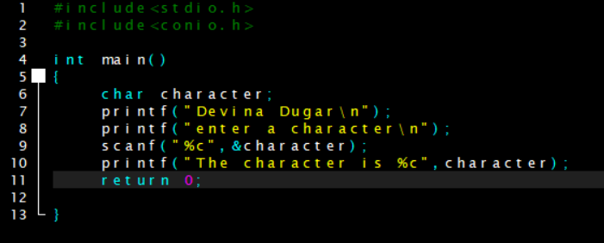

Output:

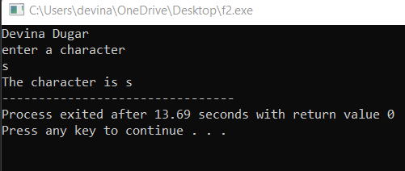

1. WAP to calculate the percentage and average of five subjects.

Coding:

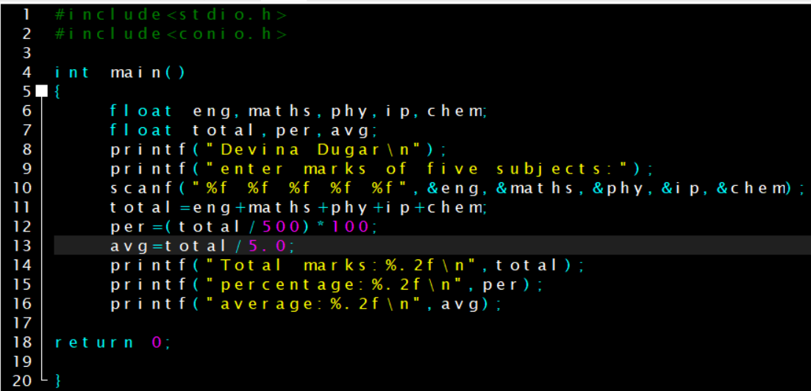

Output:

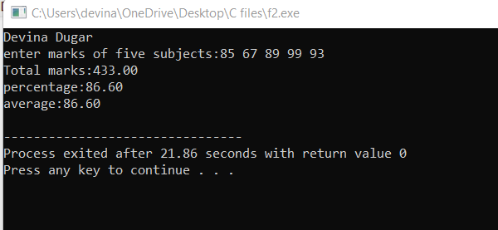

1. WAP to check number are equal or not using conditional operator.

Coding:

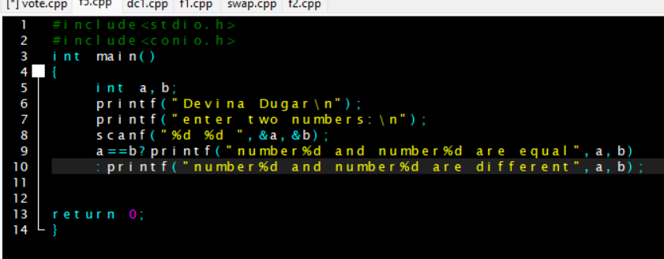

Output:

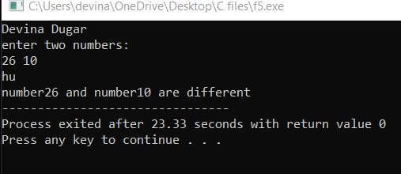

1. WAP to print max of three numbers using conditional operator.

Coding:

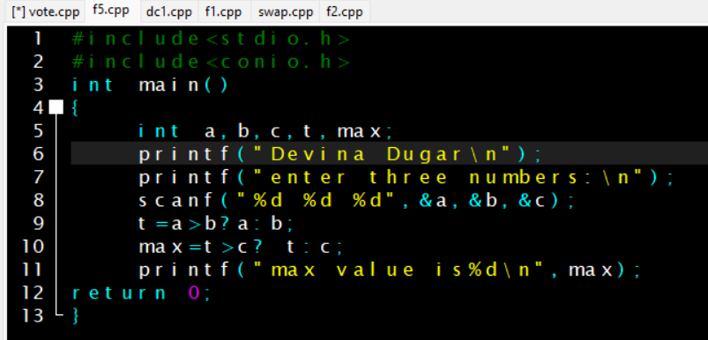

Output:

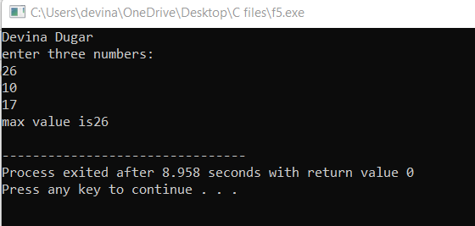

1. WAP to find area and perimeter of a circle.

Coding:

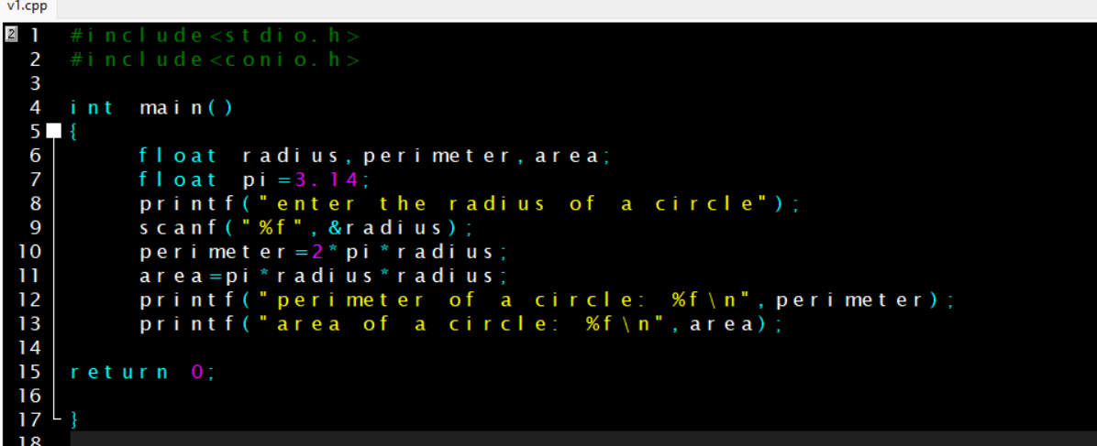

Output:

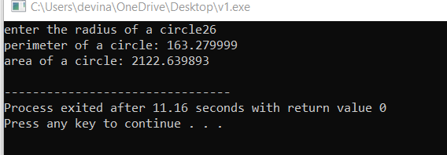

1. WAP to calculate the area of rectangle.

Coding:

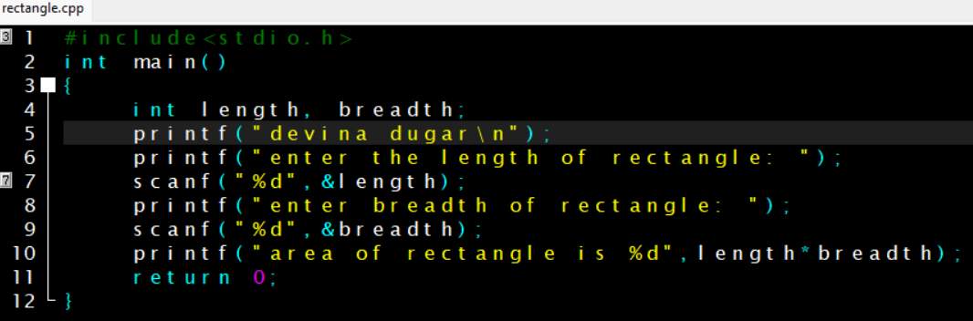

Output:

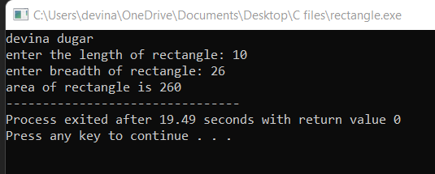

1. WAP to demonstrate “size of” operator.

Coding:

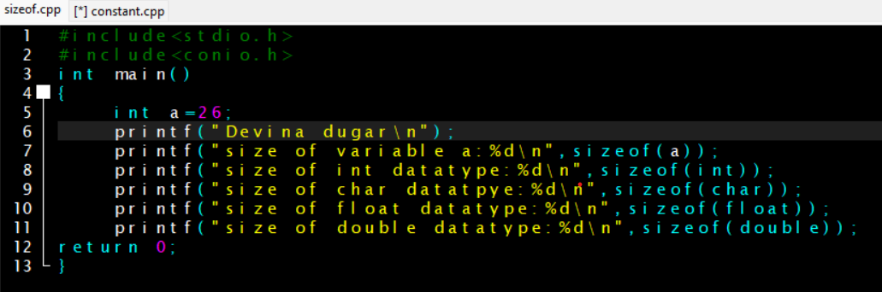

Output:

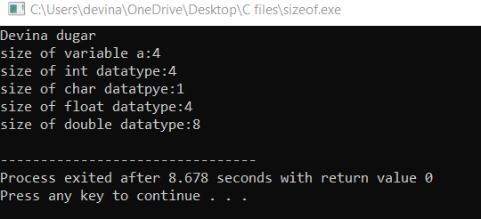

1. WAP to swap two variables using third variable.

Coding:

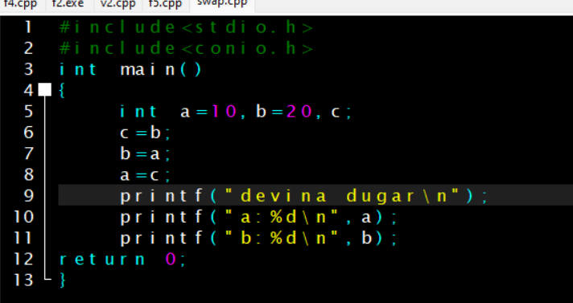

Output:

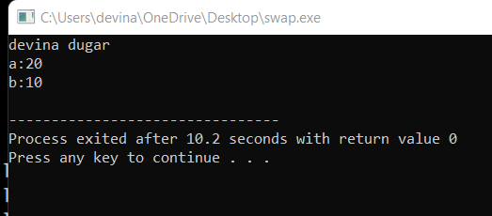

1. WAP to swap two variables without using third variable.

Coding:

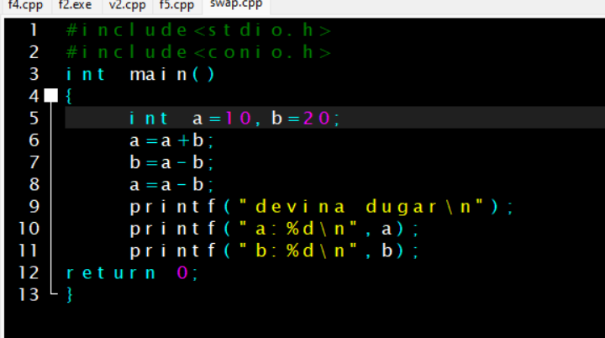

Output:

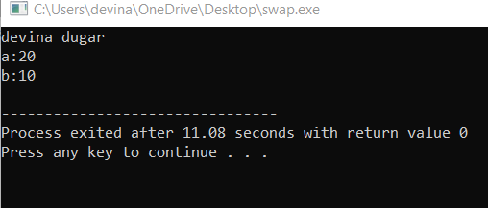

1. WAP to check the human is eligible for vote or not. Take the input from the user.

Coding:

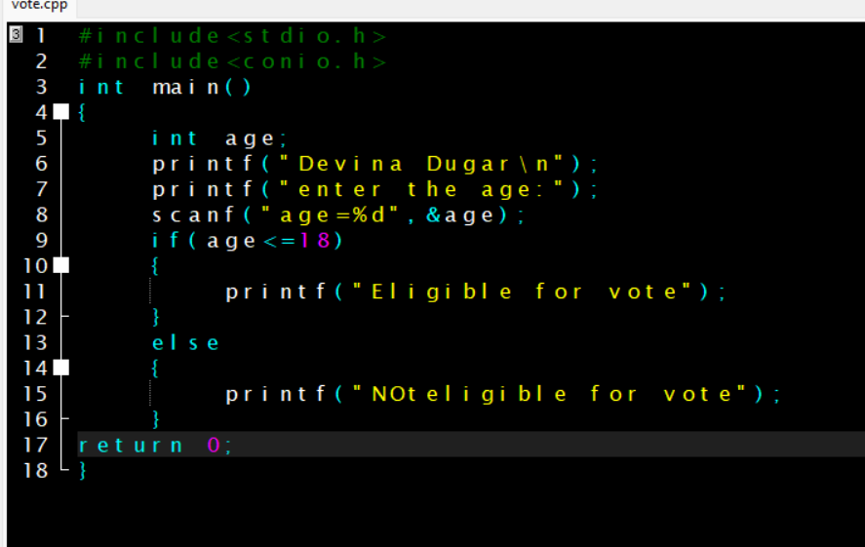

Output:

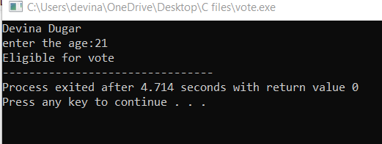

1. WAP to check whether the number entered is even or odd.

Coding:

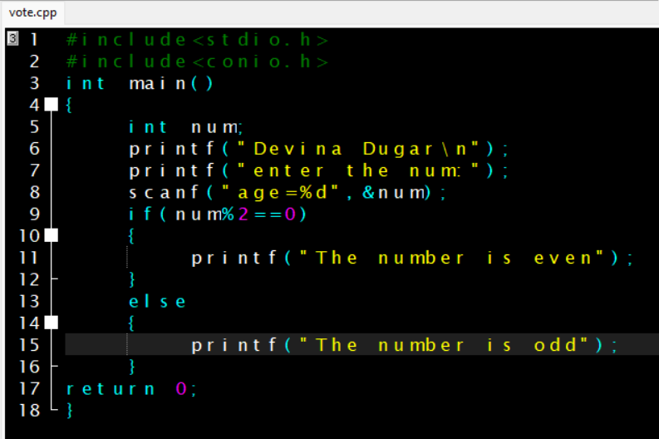

Output:

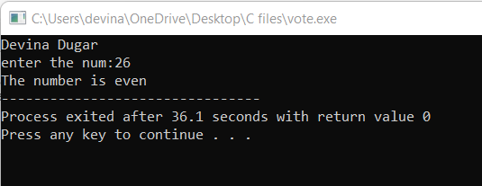

1. WAP to check number is greater than 100 and less than 1000.

Coding:

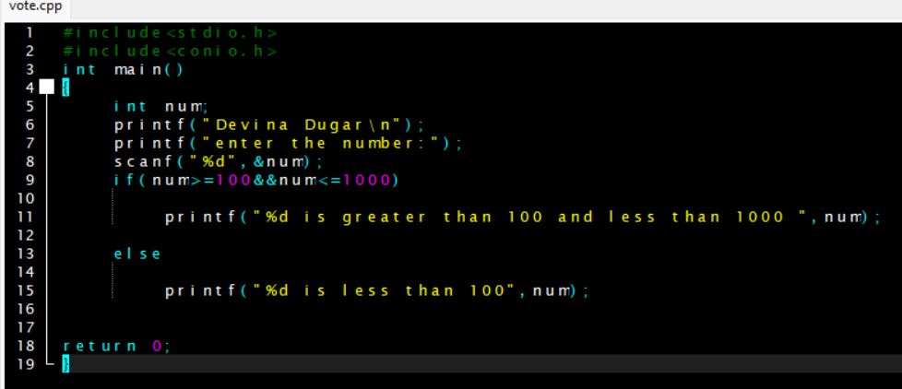

Output:

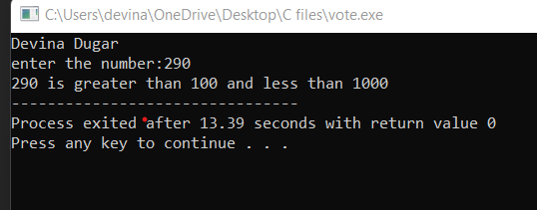

1. WAP to find the greatest and maximum of three numbers.

Coding:

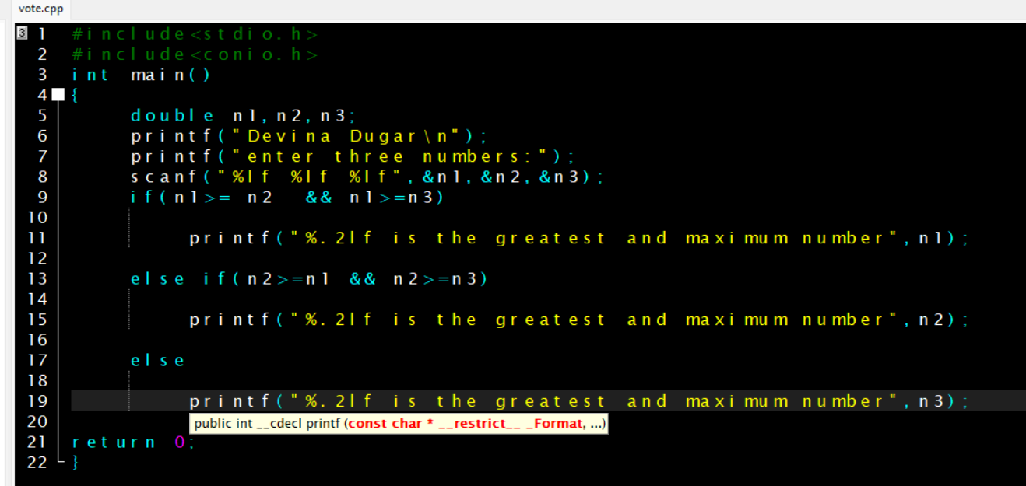

Output:

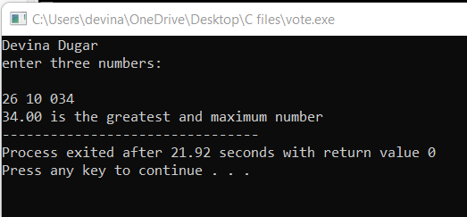

1. WAP to demonstrate post increment and pre increment and pre decrement.

Coding:

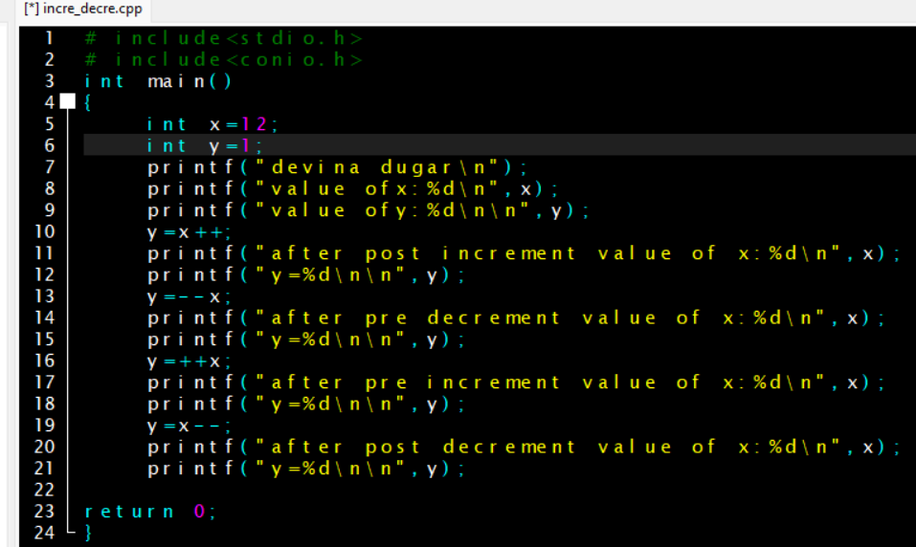

Output:

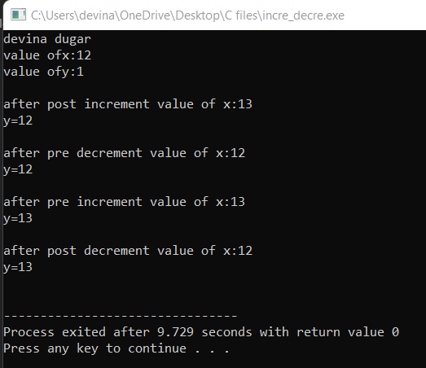

1. WAP to calculate the square of those numbers whose least significant digit is 5.

Coding:

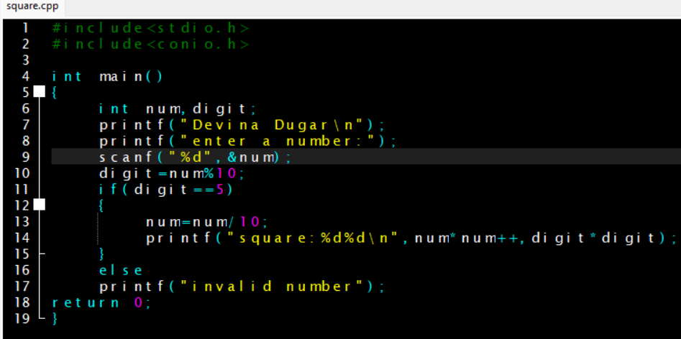

Output:

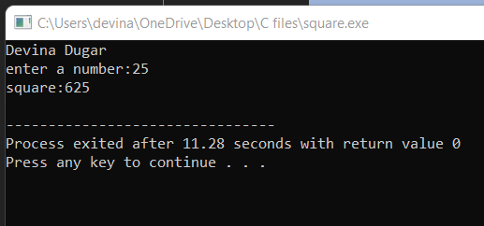

1. WAP to calculate salary of a medical sales representative based on the sales. Bonus and incentives to be offered to him will be based on total sales if the sales exceed or equal to rs.1,00,000. Follow the particulars of table1 otherwise table2.

TABLE-1 TABLE-2

* Basic-3,000 Basic - 3,000
* HRA-20% of basic HRA-20% of basic
* DA-110%of basic DA-110% of basic
* Convenyance-500 Conveyance - 500
* Incentive-10%of sales Incentive-5%of sales
* Bonus-500 Bonus-200

Coding:

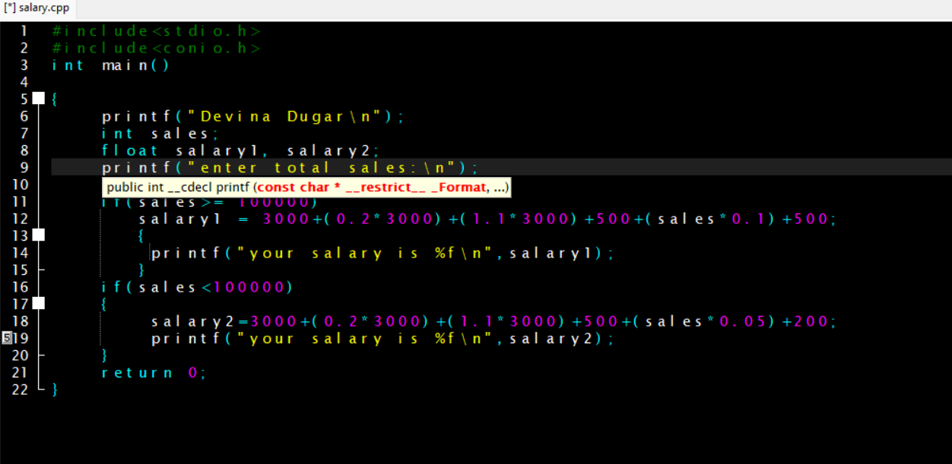

Output:

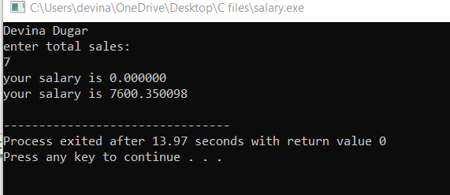

1. WAP to build a calculator using switch keyword.

Coding:

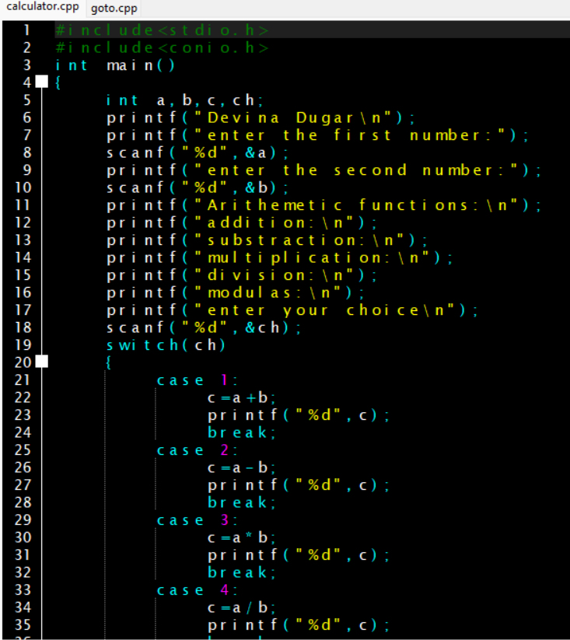

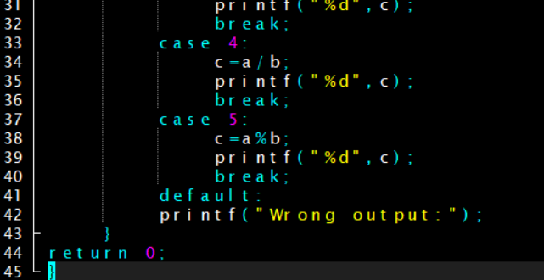

Output:

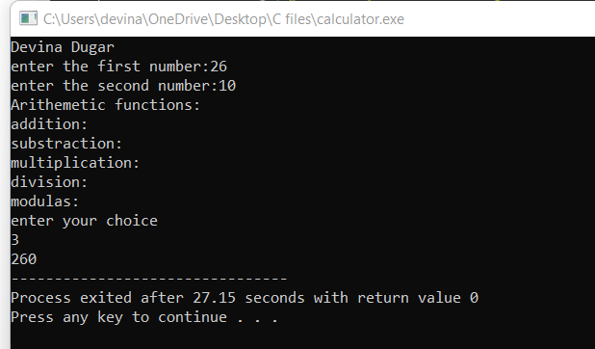

1. WAP to show whether the number is even or odd using goto keyword.

Coding:

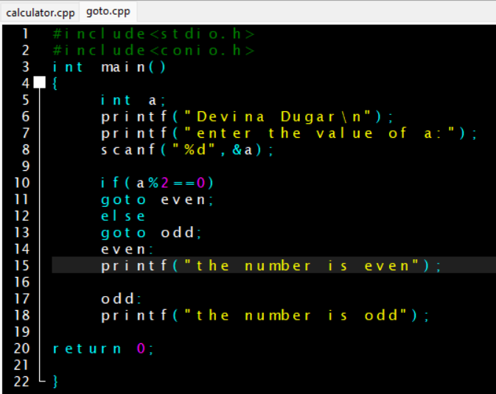

Output:

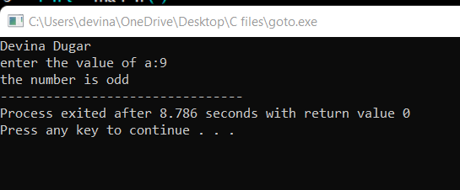

1. WAP to convert temperature from ◦c to ◦f by taking input from the user.

Coding:

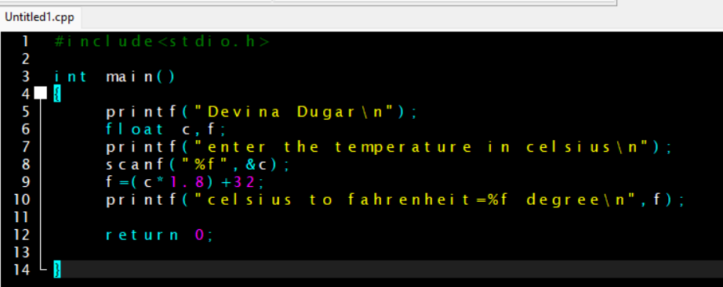

Output:

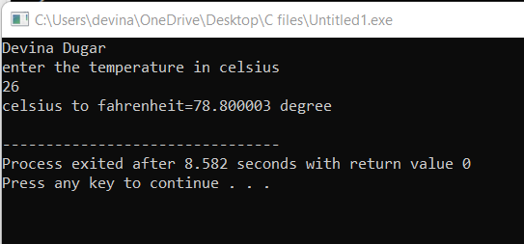

1. Write a menu driven program to construct a calculator.

Coding:

Output:

1. WAP to calculate SI and CI input taken by user.

Coding:

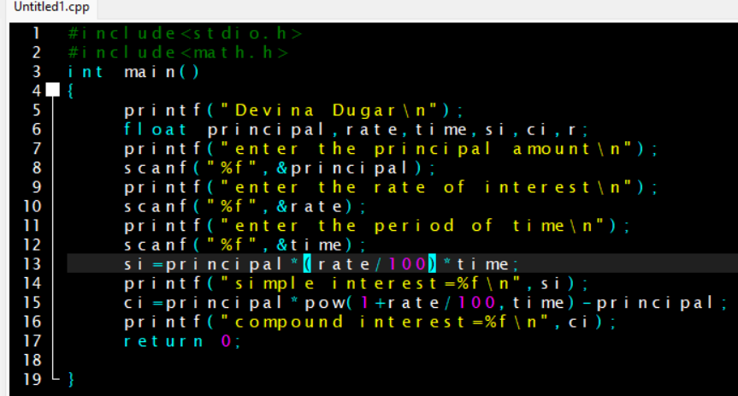

Output:

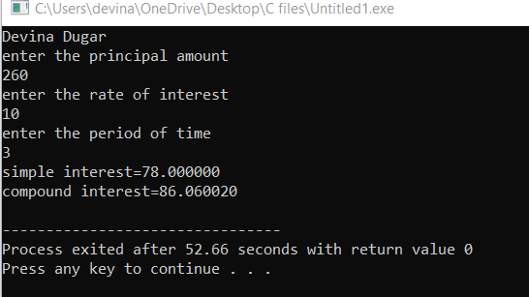

1. WAP to print first five number starting from 1 together with their square.

Coding:

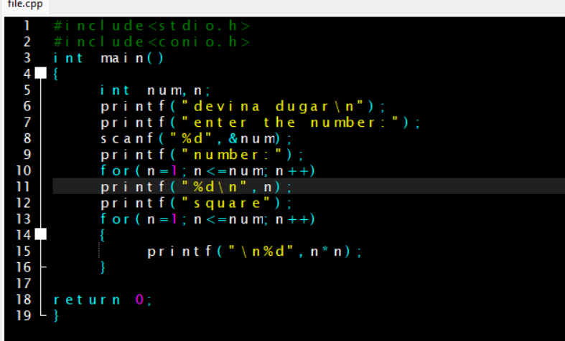

Output:

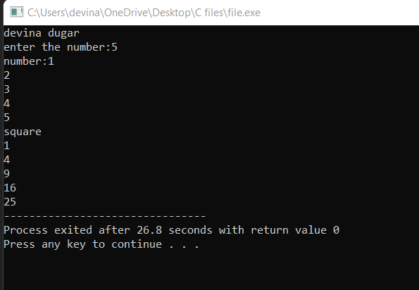

1. WAP to print table of 2.

Coding:

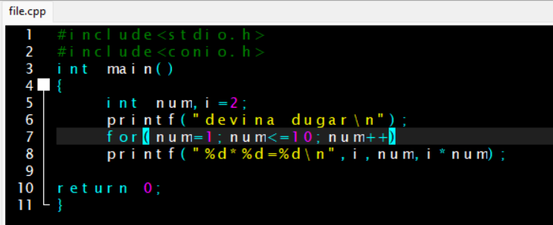

Output:

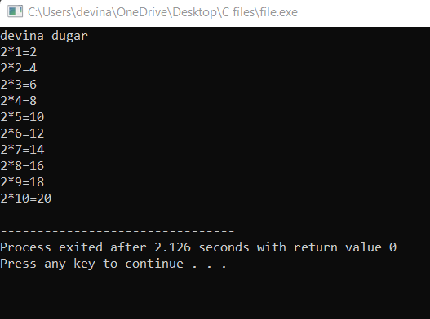

1. WAP a program to find the sum of following series.

Coding:

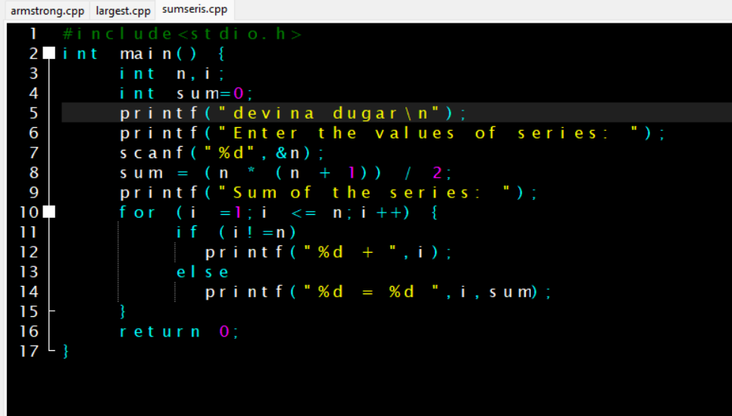

Output:

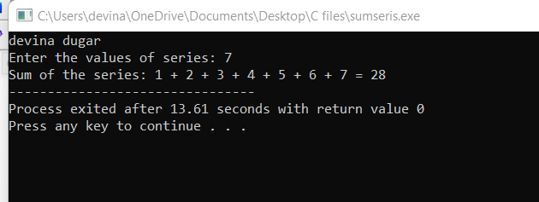

1. WAP to find the perfect square from from 1 to 500.

Coding:

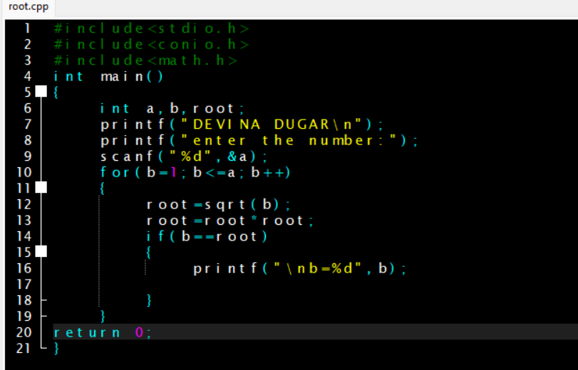

Output:

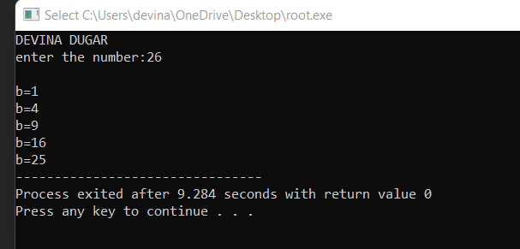

1. WAP to print a reverse series 100 to 1.

Coding:

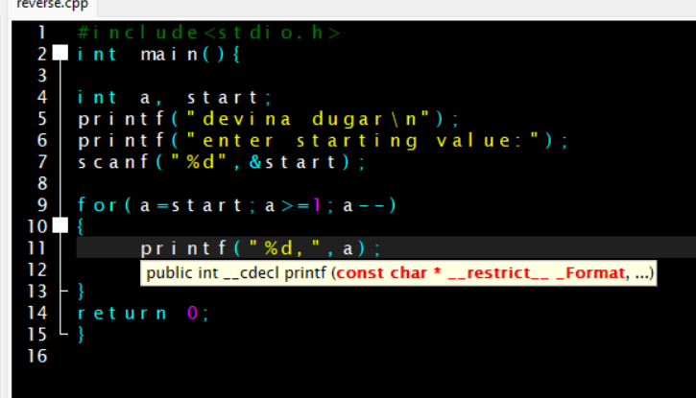

Output:

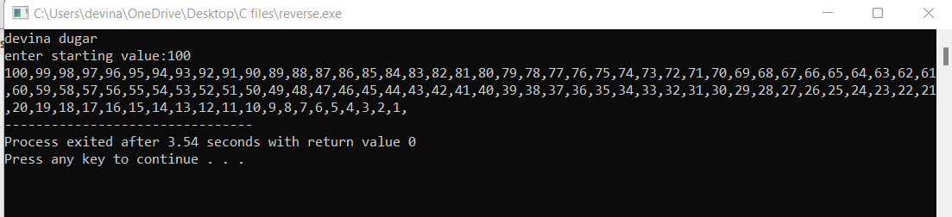

1. WAP to print factorial of a given number.

Coding:

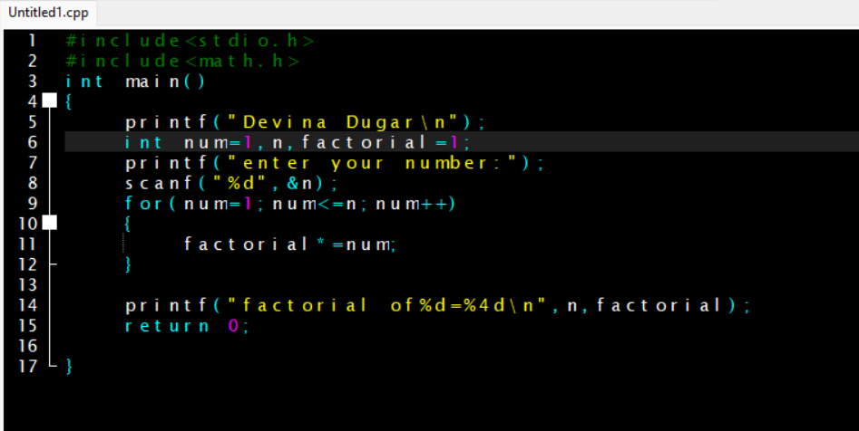

Output:

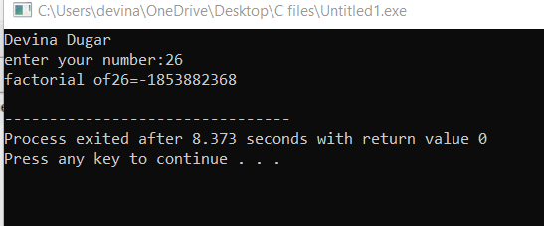

1. WAP to print Fibonacci series till the nth pattern.

Coding:

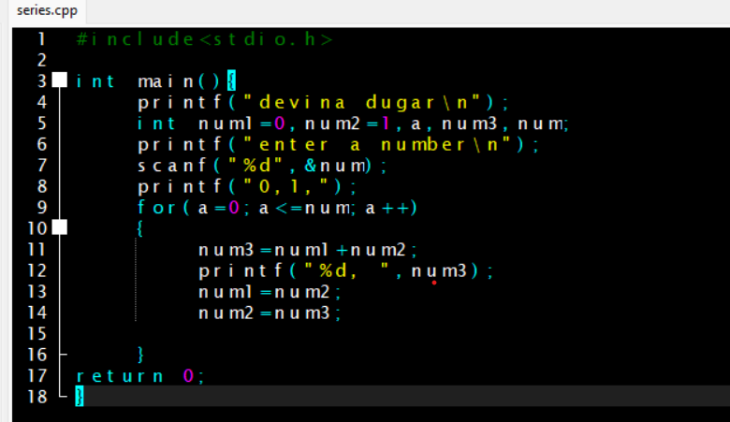

Output:

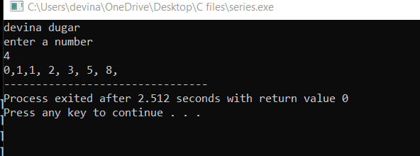

1. WAP to count the number of students having age less than 25 and weight less than 50kg.

Coding:

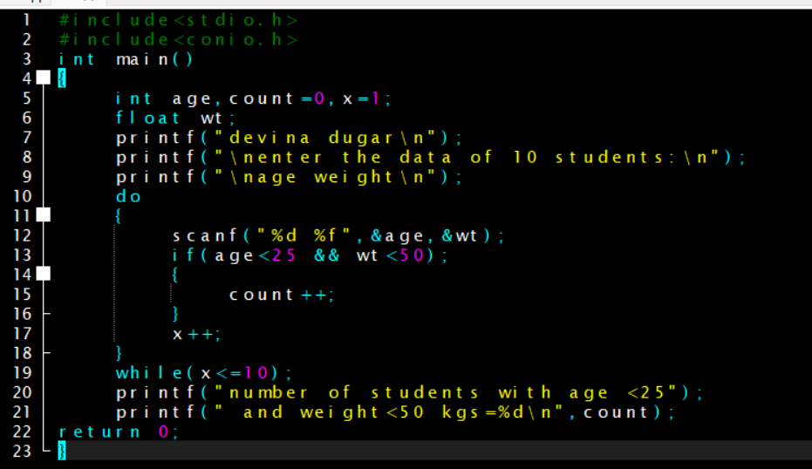

Output:

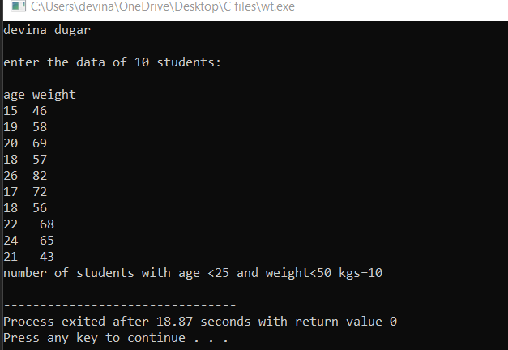

1. WAP to print diamond pattern (taking number of rows as input from the user.)

Coding:

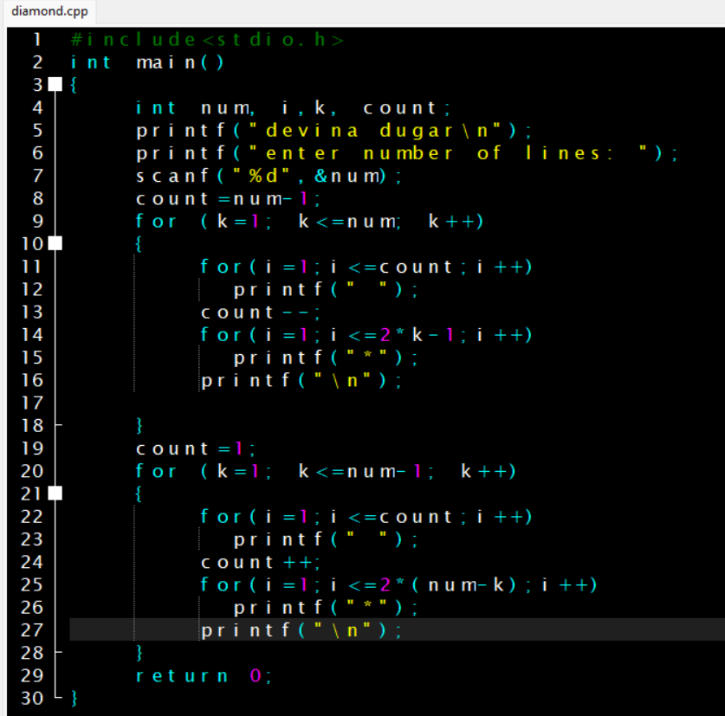

Output:

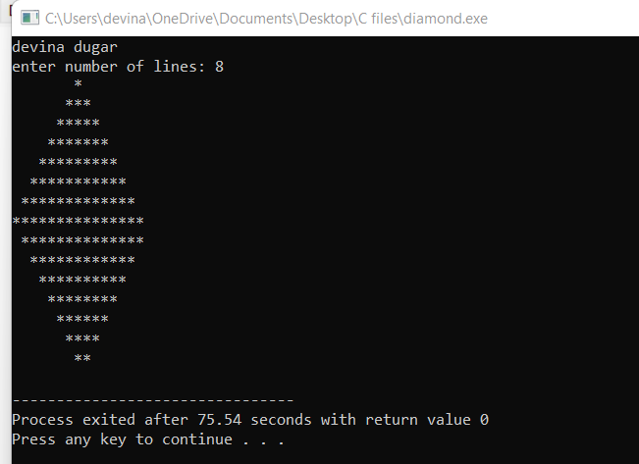

1. WAP to reverse the number entered by the user.

Coding:

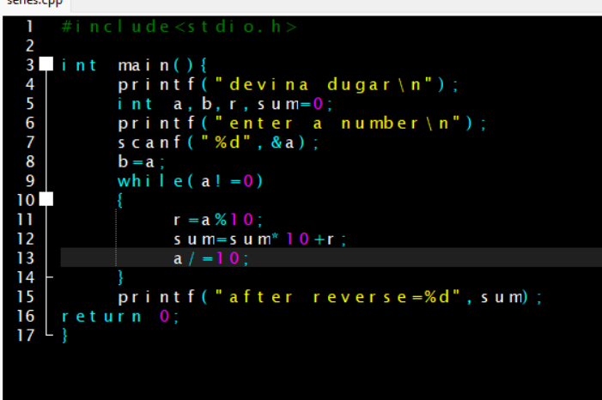

Output:

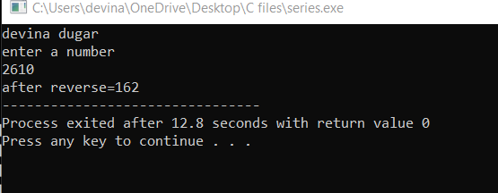

1. WAP to print series from 1 to n using do-while loop.

Coding:

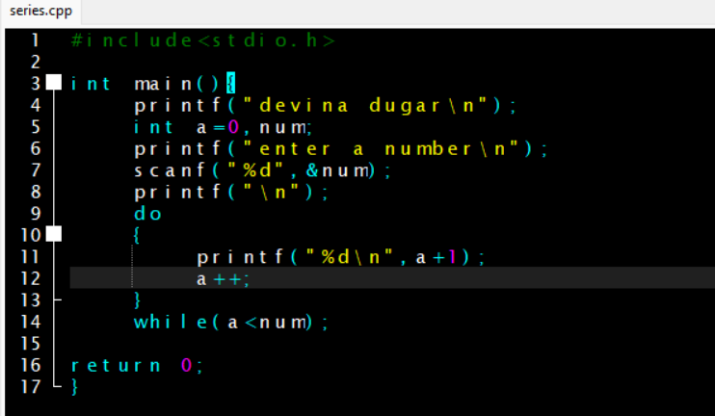

Output:

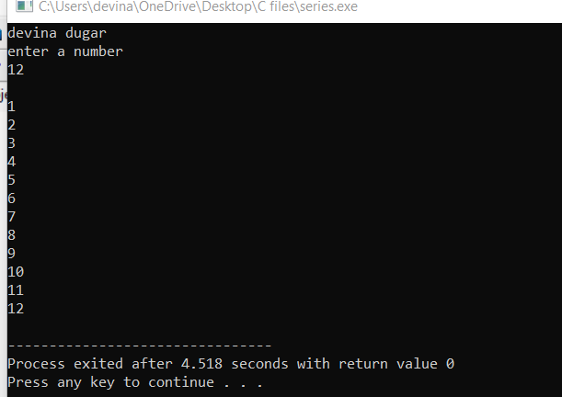

1. WAP to calculate the square and sum of the digits of a series from 1 to n same as the question above.

Coding:

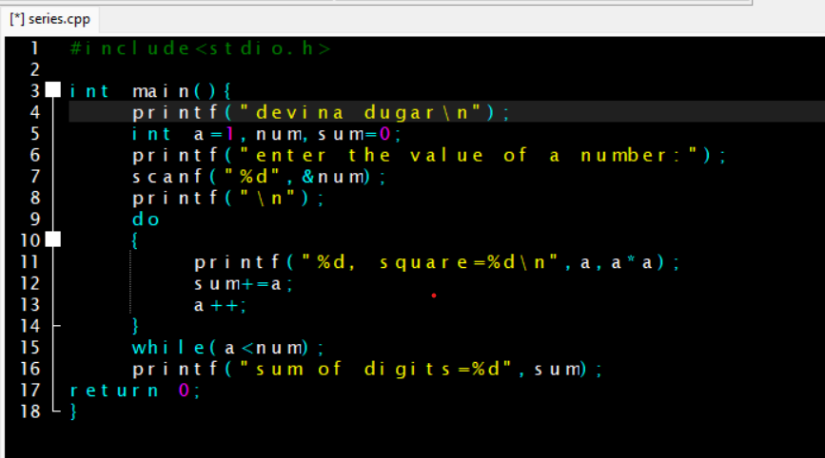

Output:

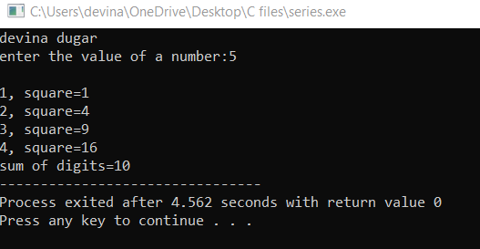

1. WAP to demonstrate the use of break keyword.

Coding:

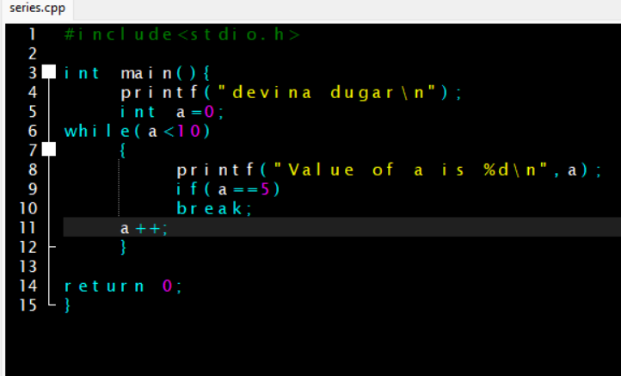

Output:

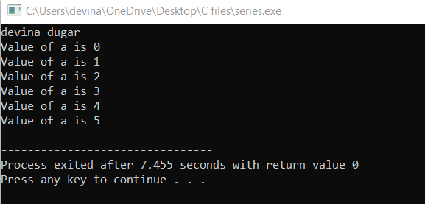

1. WAP to check whether a number is a palindrome or not.

Coding:

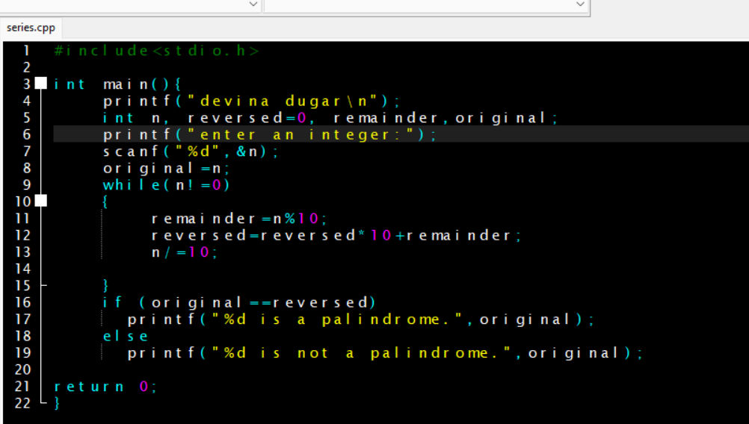

Output:

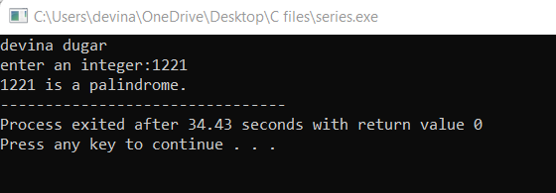

1. WAP to check whether a number is Armstrong or not.

Coding:

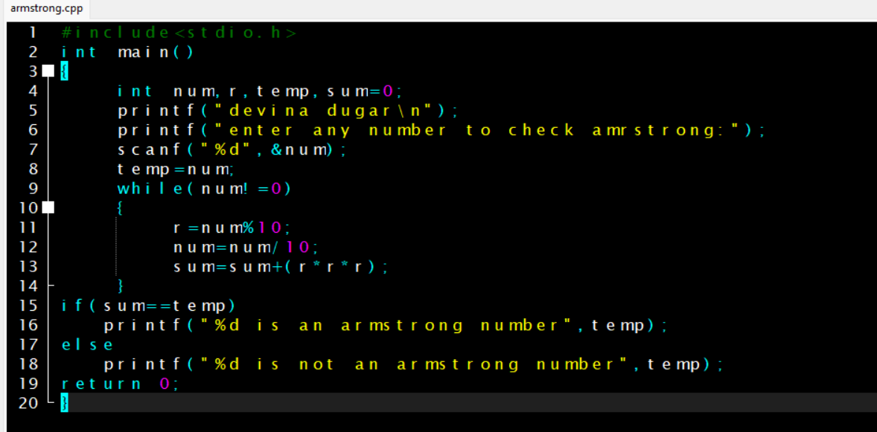

Output:

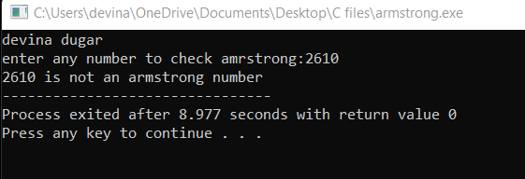

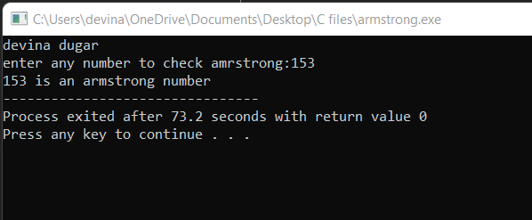

1. WAP to print morning, evening and night using functions. (Without argument and without return value)

Coding:

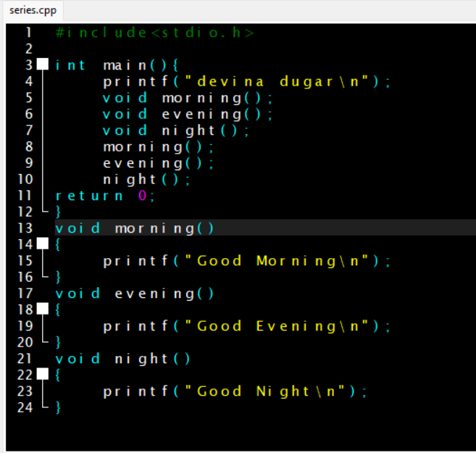

Output:

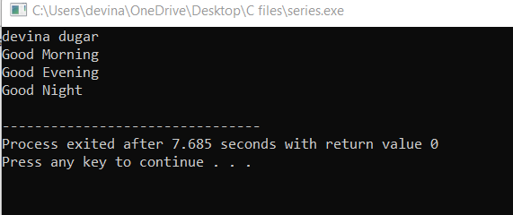

1. WAP to check whether the number is given is prime or not, using user define function (without argument or return type).

Coding:

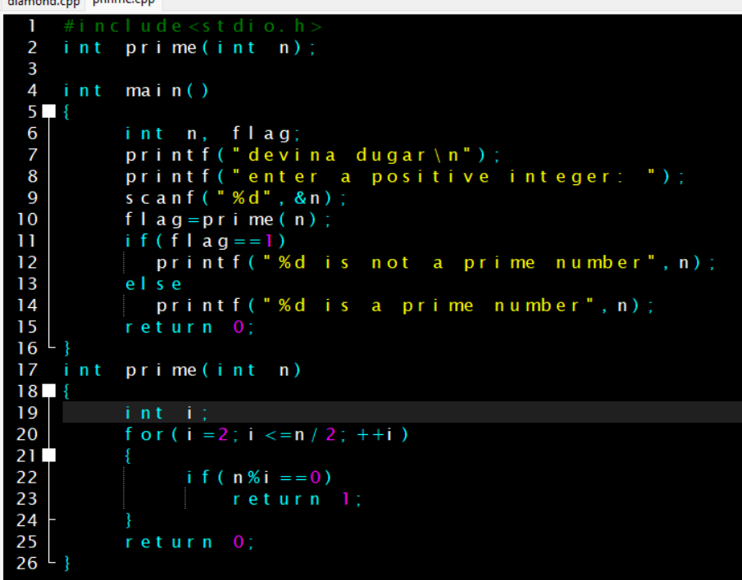

Output:

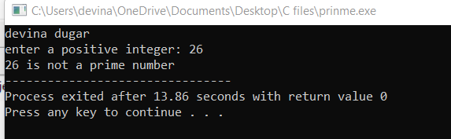

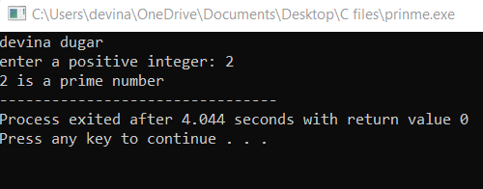

1. WAP to check whether the number is given is prime or not, using user define function (with argument &with return type).

Coding:

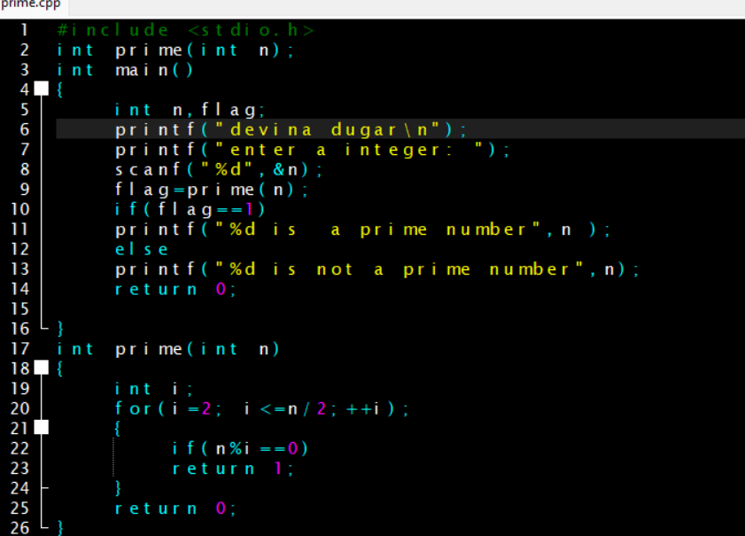

Output:

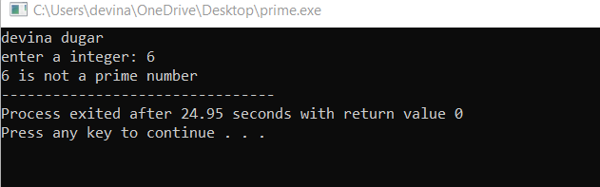

1. WAP to calculate the square of numbers from 1-5 using a user defined function. (With argument & without return value)

Coding:

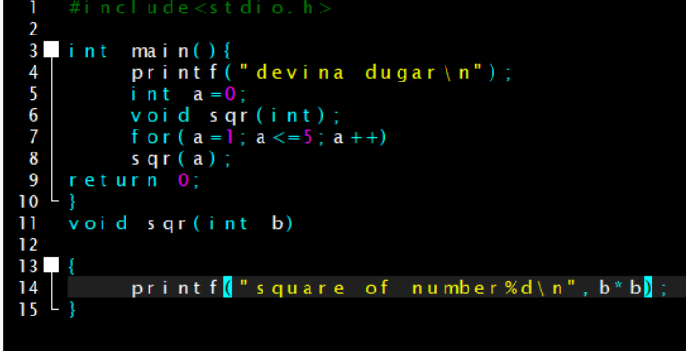

Output:

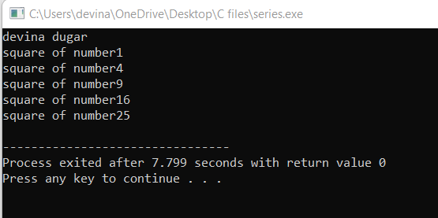

1. WAP to calculate the average of three numbers using functions. (With argument & with return value)

Coding:

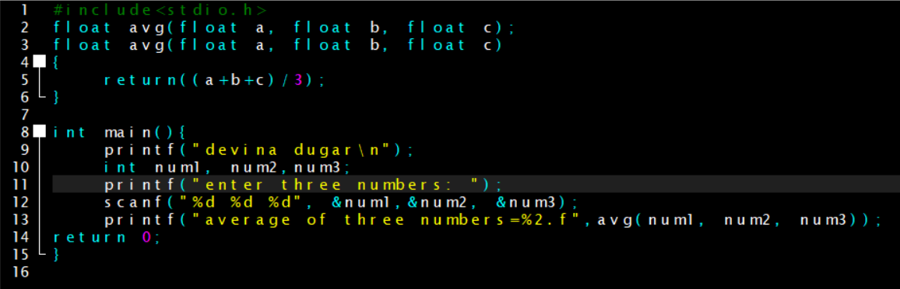

Output:

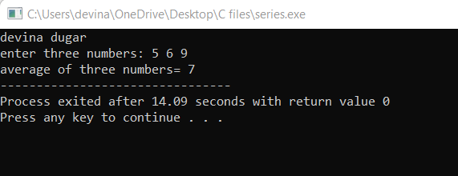

1. WAP to calculate the sum of variables using functions.

Coding:

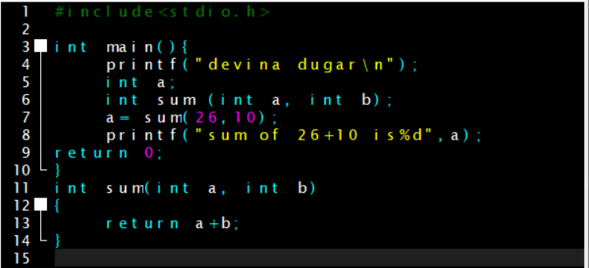

Output:

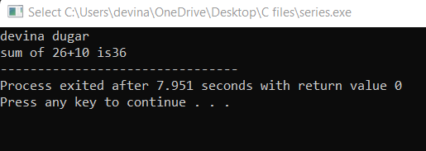

1. WAP to describe the call by reference concept in functions by swapping two variables with the help of third variable.

Coding:

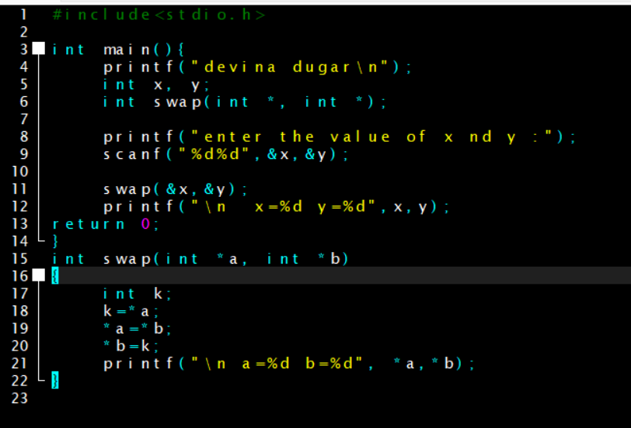

Output:

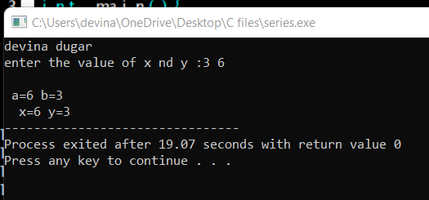

1. WAP to skip a number in a series using continue.

Coding:

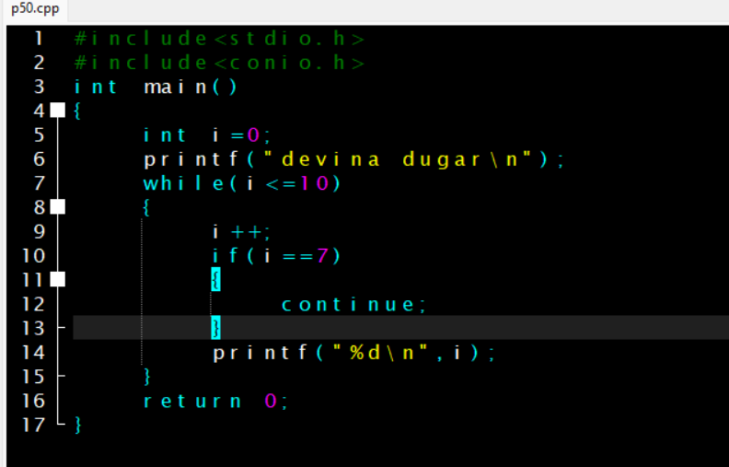

Output:

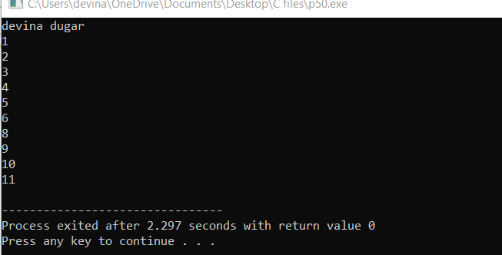

1. WAP to display the following pattern n rows and rows taking the value of n from the user.

/*1

2 3

4 5 6

7 8 9 10

11 12 13 14 15*/

Coding:

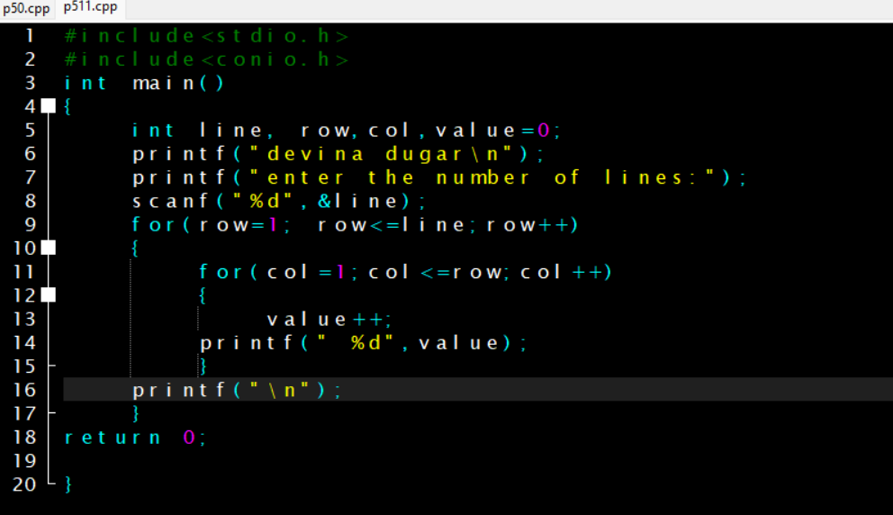

Output:

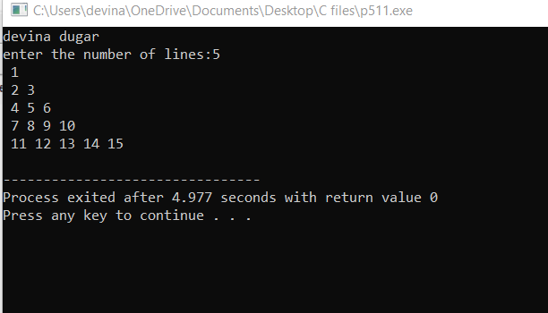

1. WAP to print alphabetical pattern.

Coding:

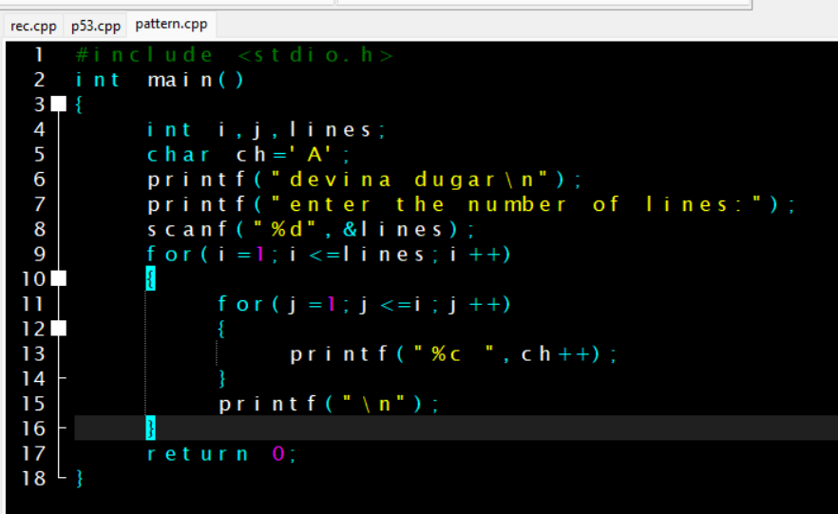

Output:

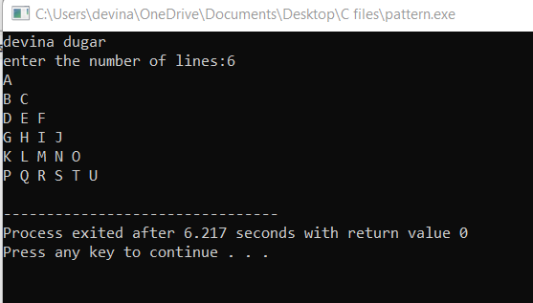

1. WAP to exchange the value of two variable by call by value of the function.

Coding:

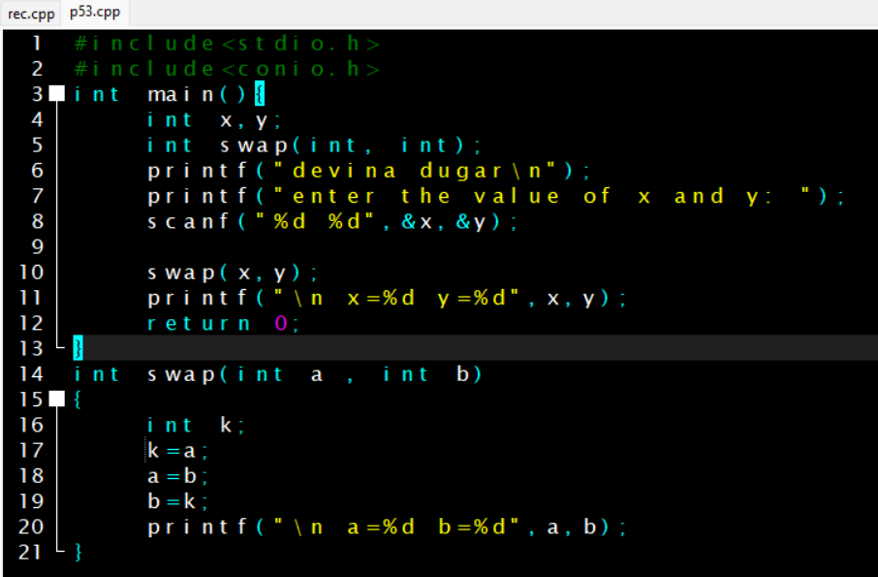

Output:

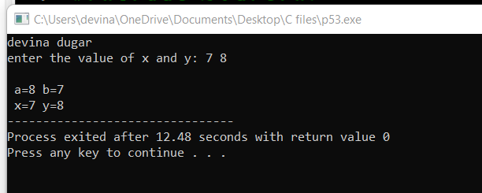

1. WAP to exchange the value of two variable by call by reference of the function.

Coding:

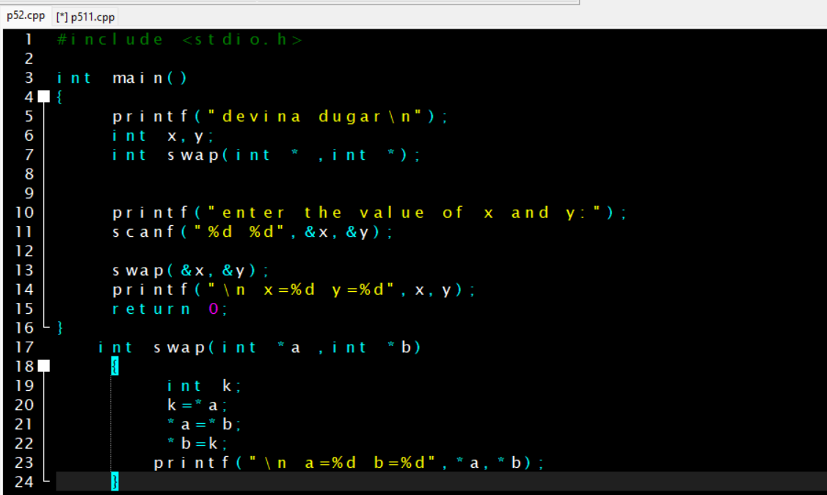

Output:

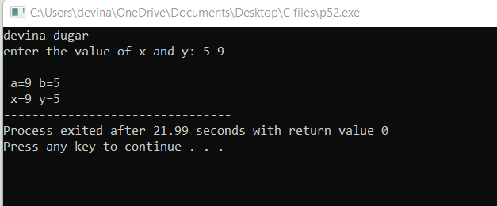

1. WAP to print numbers and their sum up to five using recursion.

Coding:

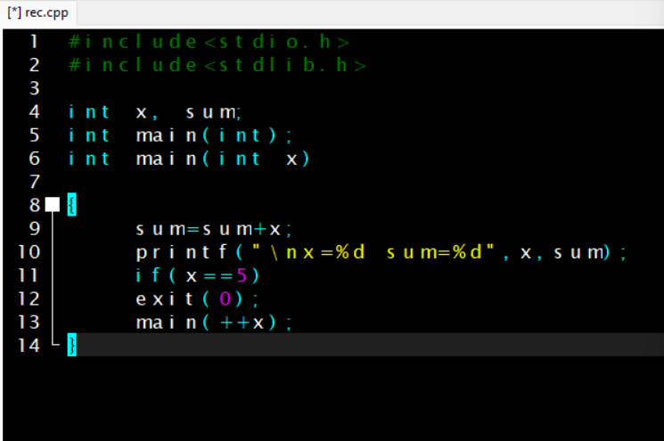

Output:

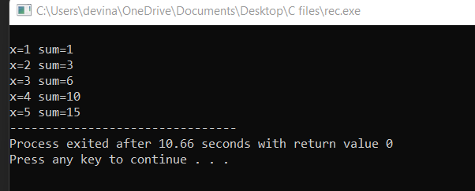

1. WAP using recursion to display sum of digits of a given number.

Coding:

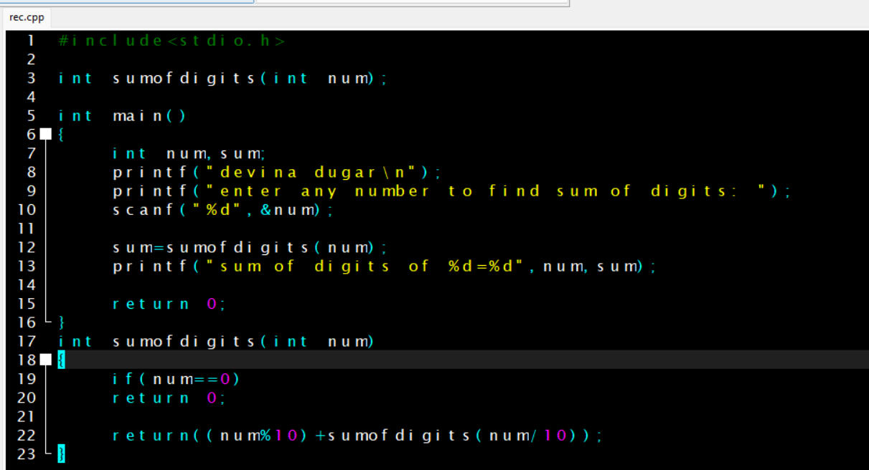

Output:

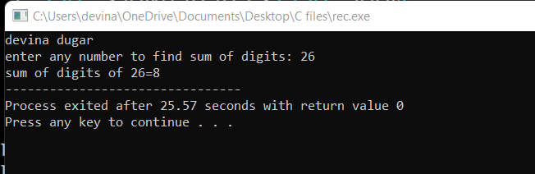

1. WAP to display element of two array in two separate columns at their corresponding element. Display the result of addition in third column.
2. WAP to find min and max element of array.

Coding:

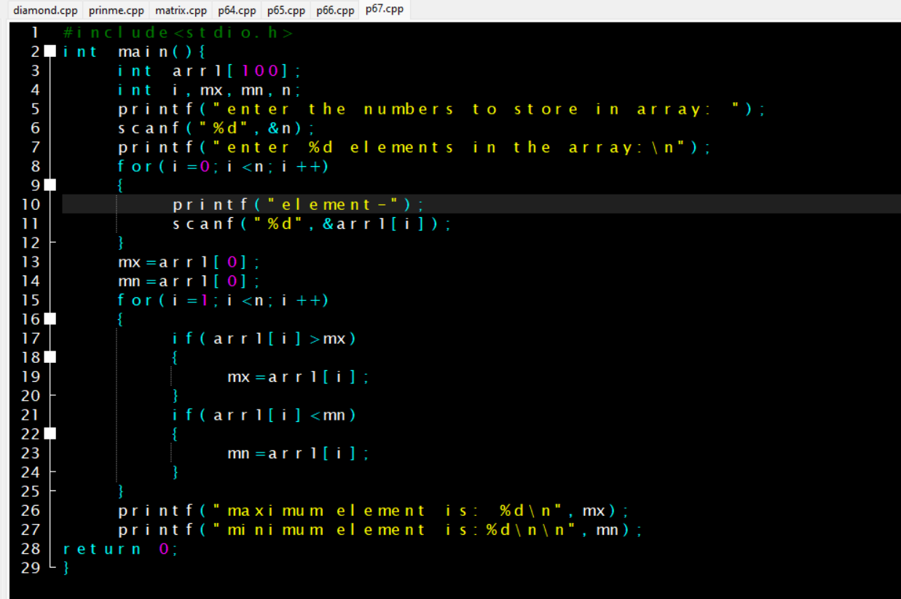

Output:

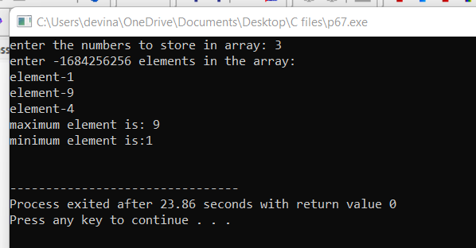

1. WAP to find remainder and quotient of given dividend and divisor.

Coding:

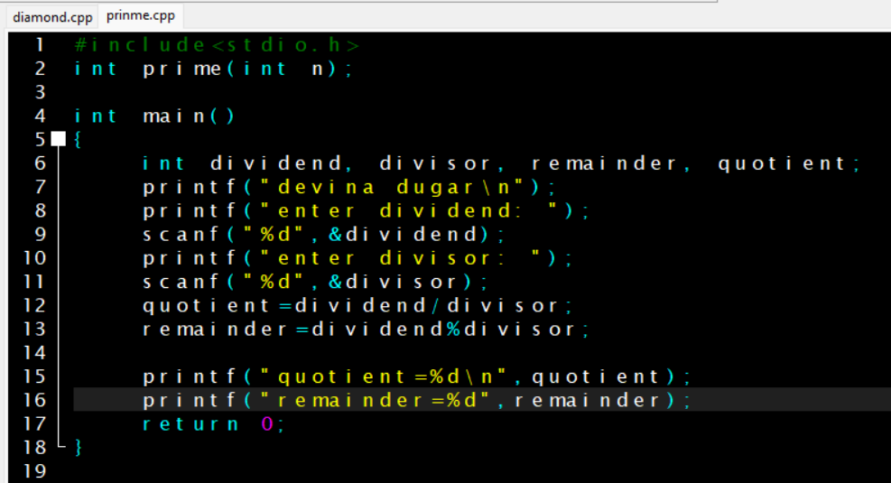

Output:

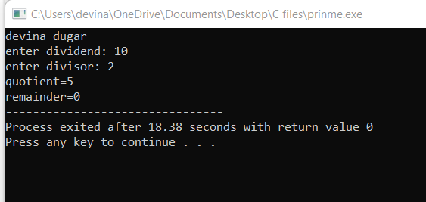

1. WAP to find largest number among three number using logics and operator.

Coding:

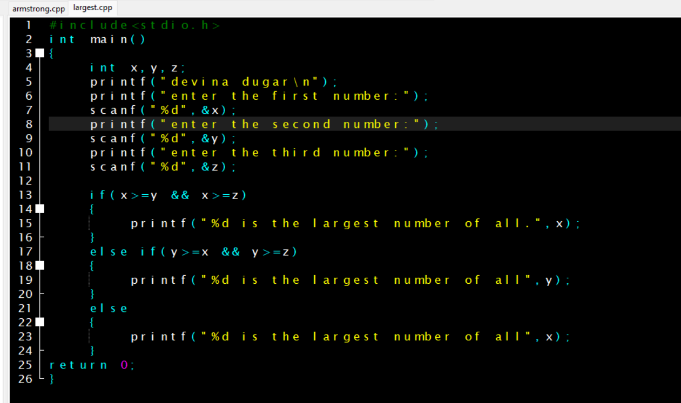

Output:

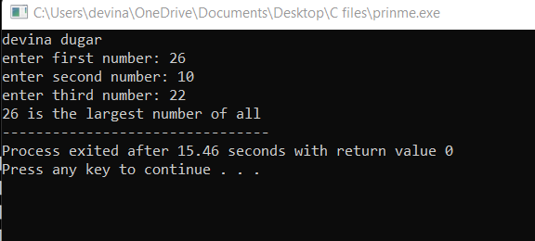

1. WAP to print an array element and their address side by side.

Coding:

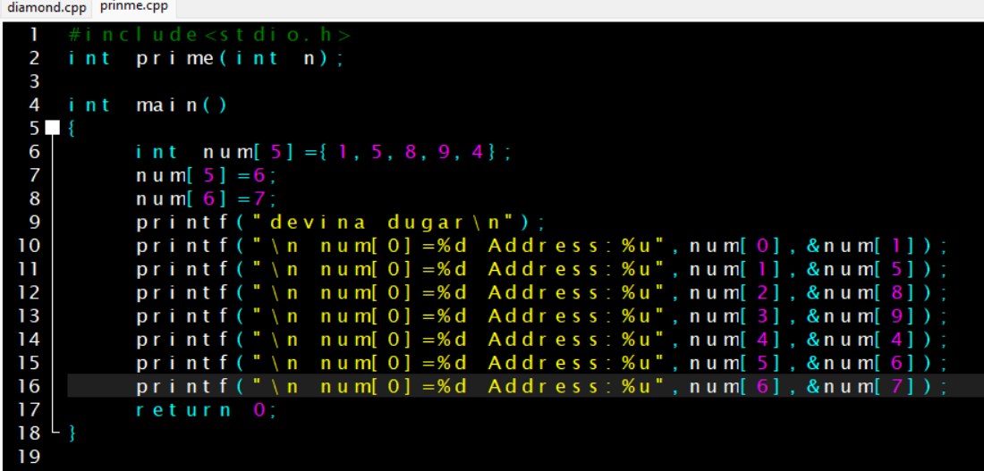

Output:

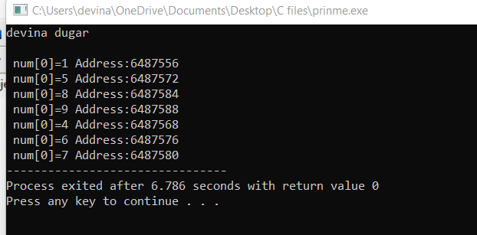

1. WAP to print array elements and their address take array length input from user.

Coding:

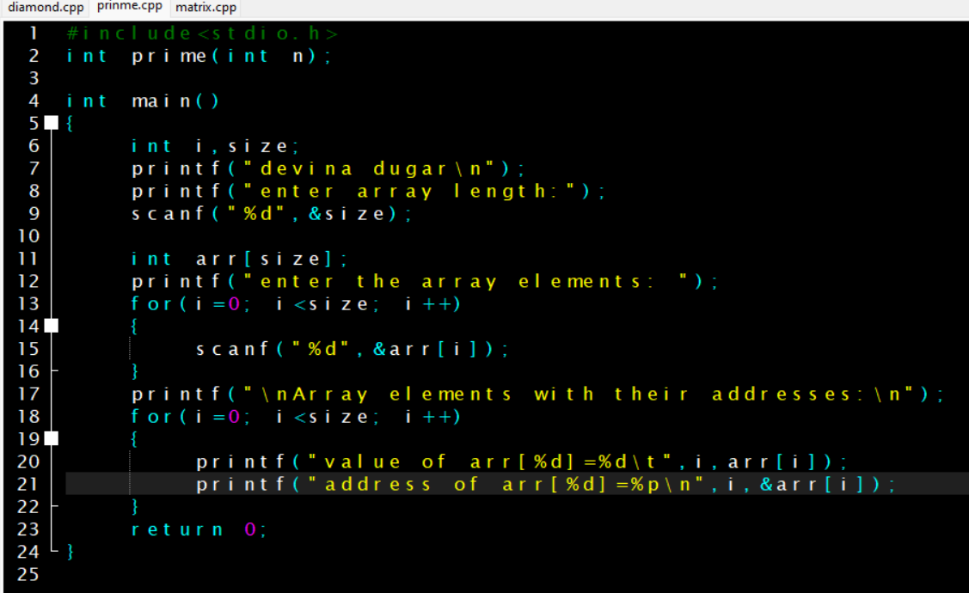

Output:

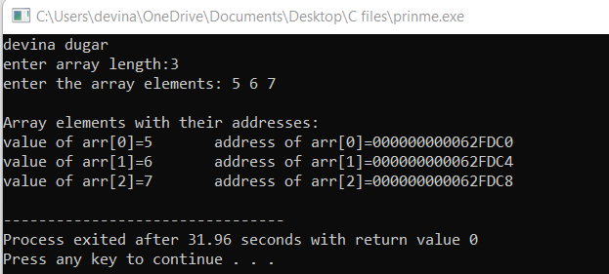

1. WAP to find given year is a leap or not using an array.

Coding:

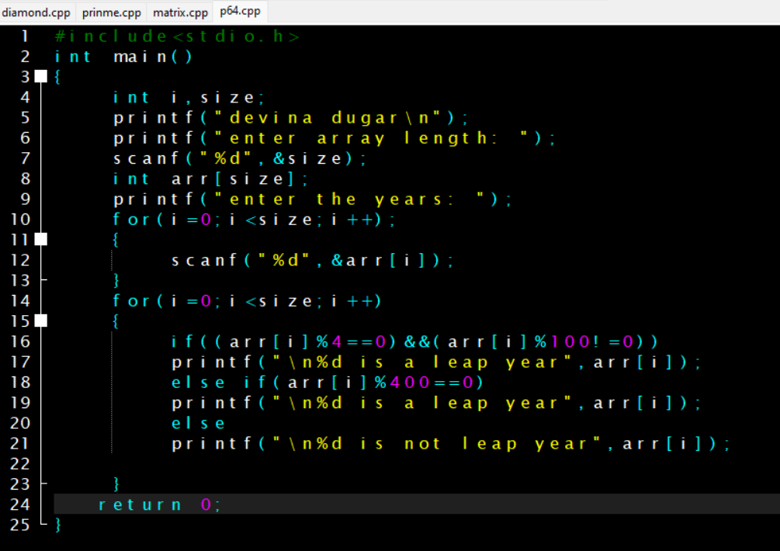

Output:

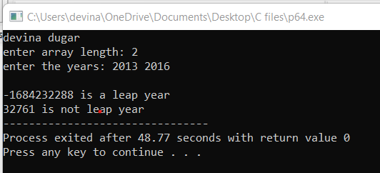

1. WAP to find the sum of odd and even numbers from an array take array length and elements input from user.

Coding:

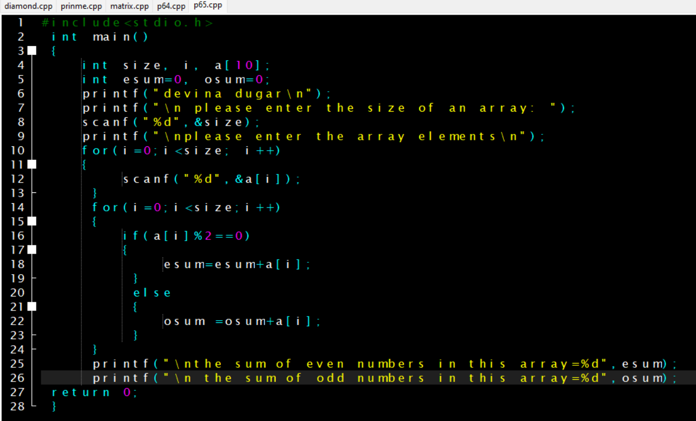

Output:

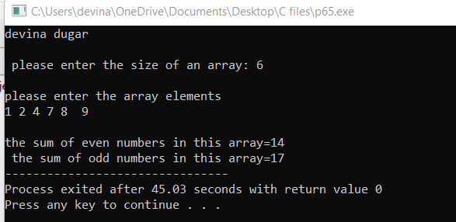

1. WAP to check the occurrences of a character in a string.

Coding:

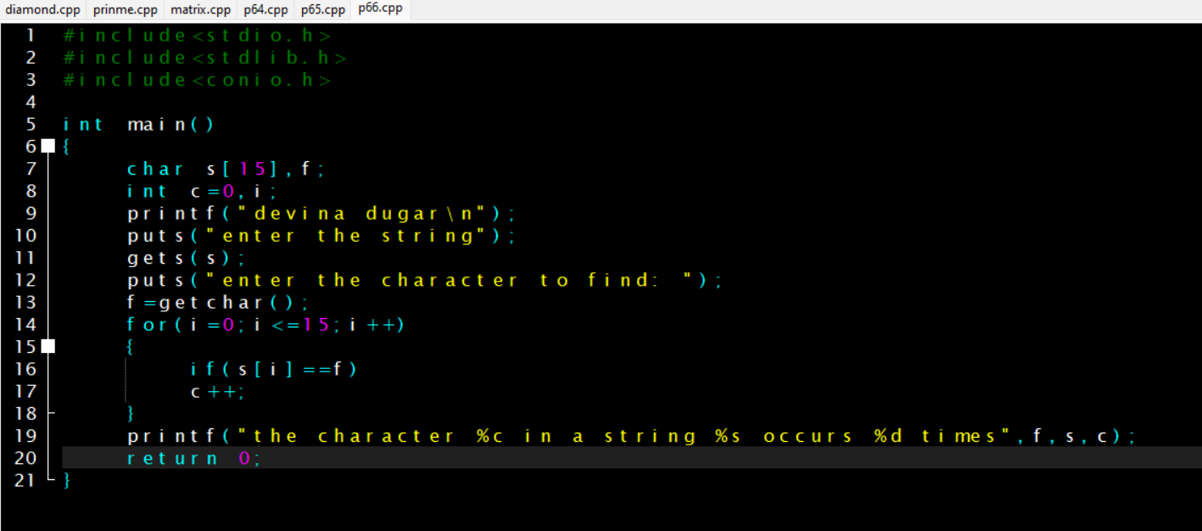

Output:

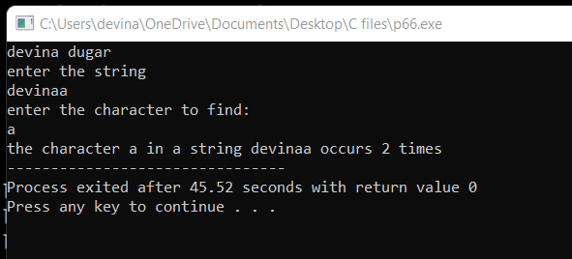

1. WAP to print an array row and column wise.

Coding:

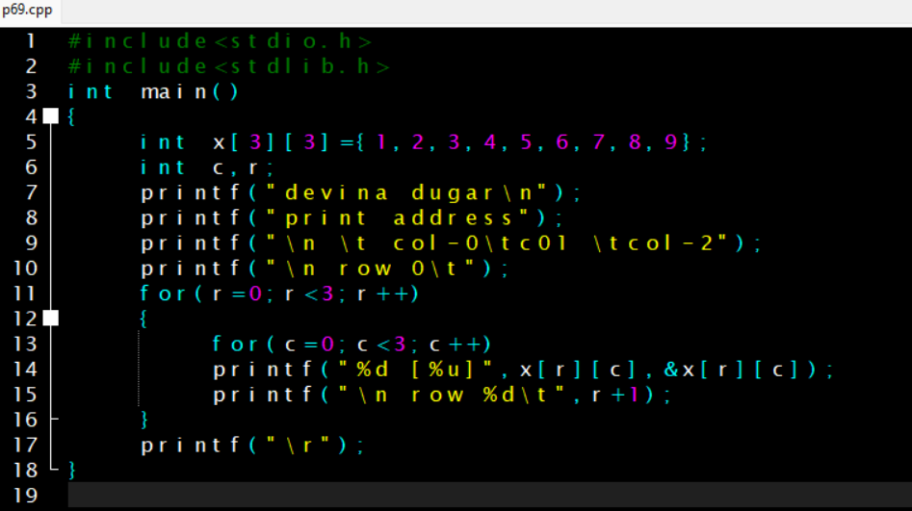

Output:

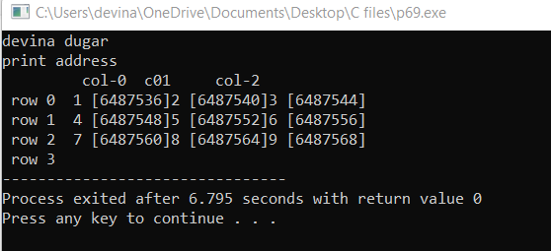

fi

1. WAP to print address of elements of an array using pointer.

Coding:

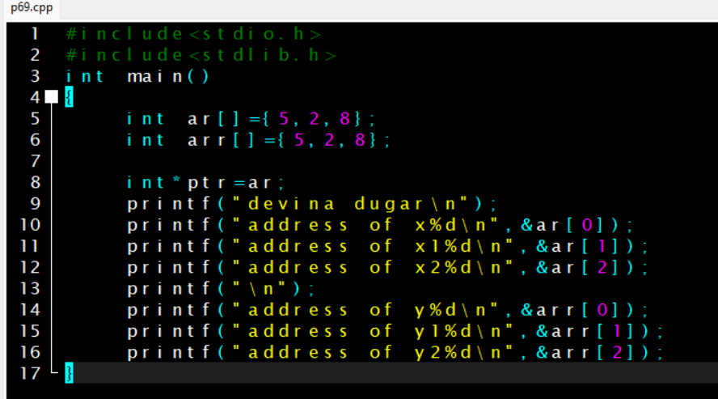

Output:

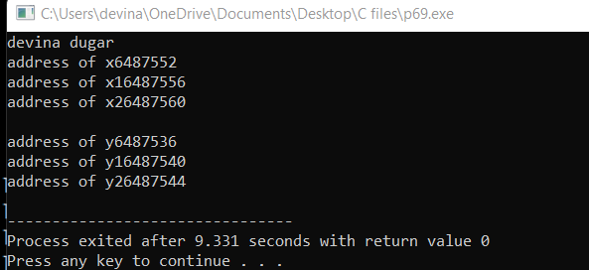

1. WAP to print value of an array by index and by using pointer pointer.

Coding:

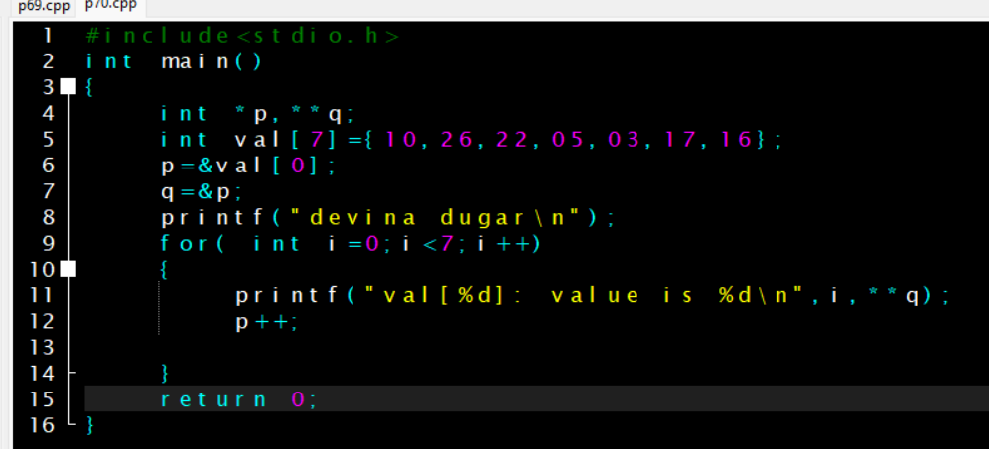

Output:

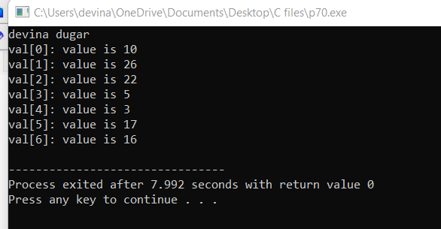

1. WAP to store n elements in an array and print the elements using pointer.

Coding:

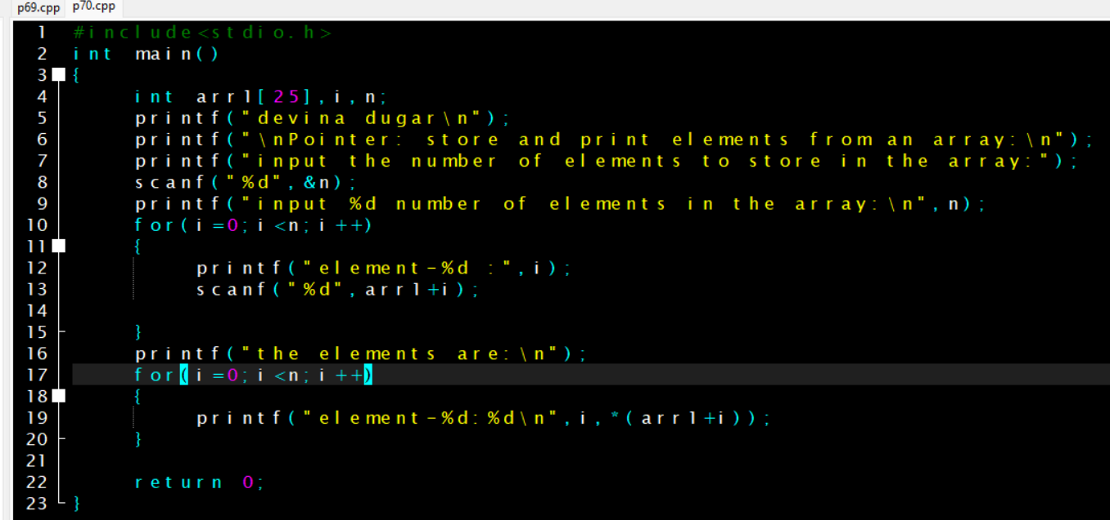

Output:

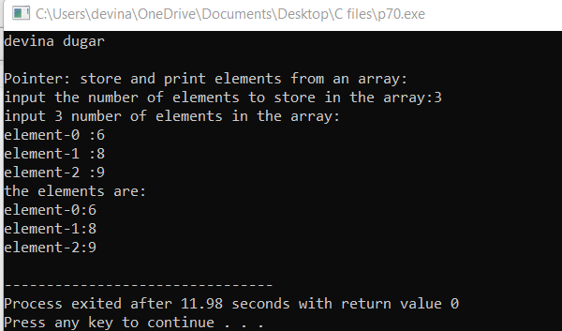

1. WAP in c to find the largest element using dynamic memory allocation.

Coding:

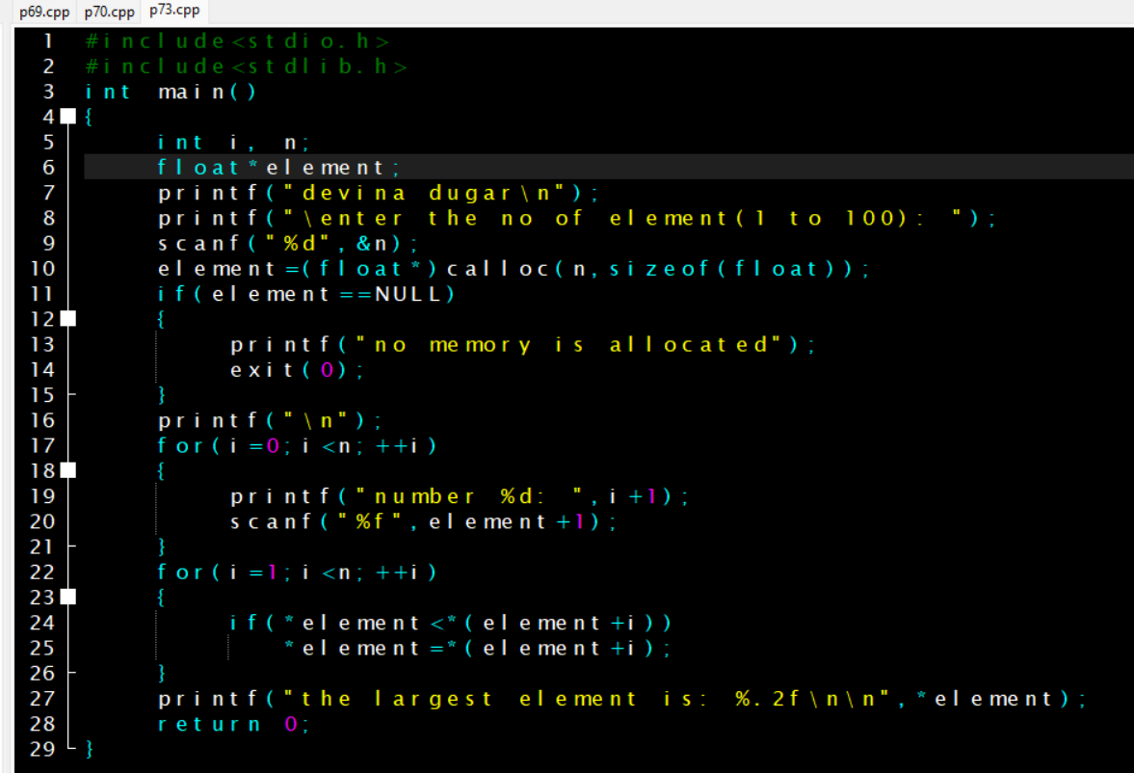

Output:

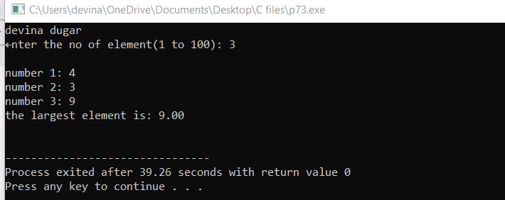

1. WAP to calculate the length of string using function.

Coding:

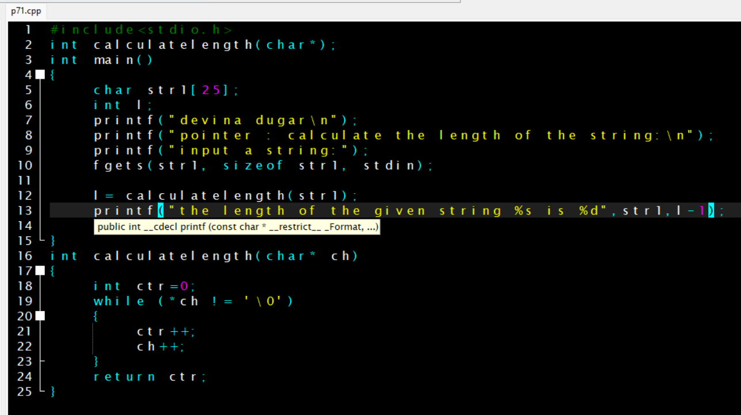

Output:

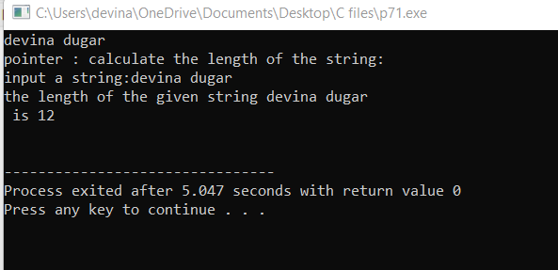

1. WAP to print reverse of a string using pointer.

Coding:

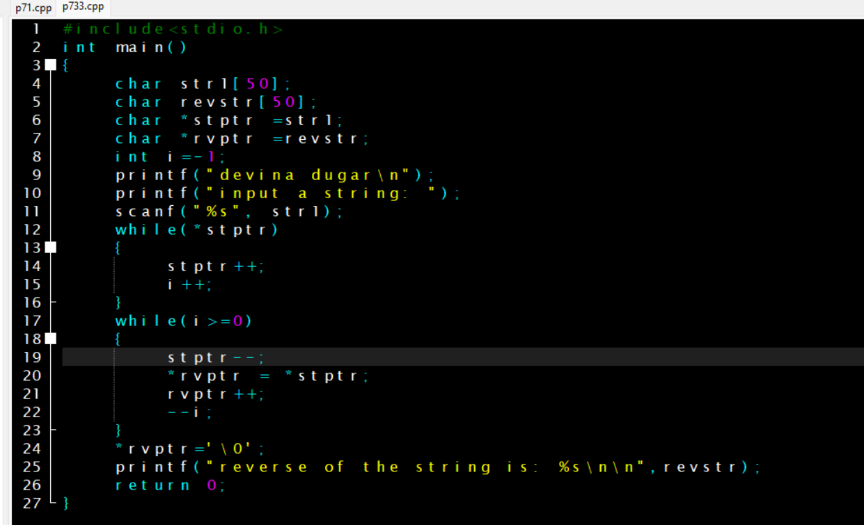

Output:

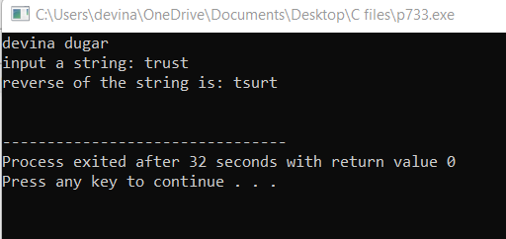

1. WAP to input elements in an array using dynamic memory allocation (use calloc).

Coding:

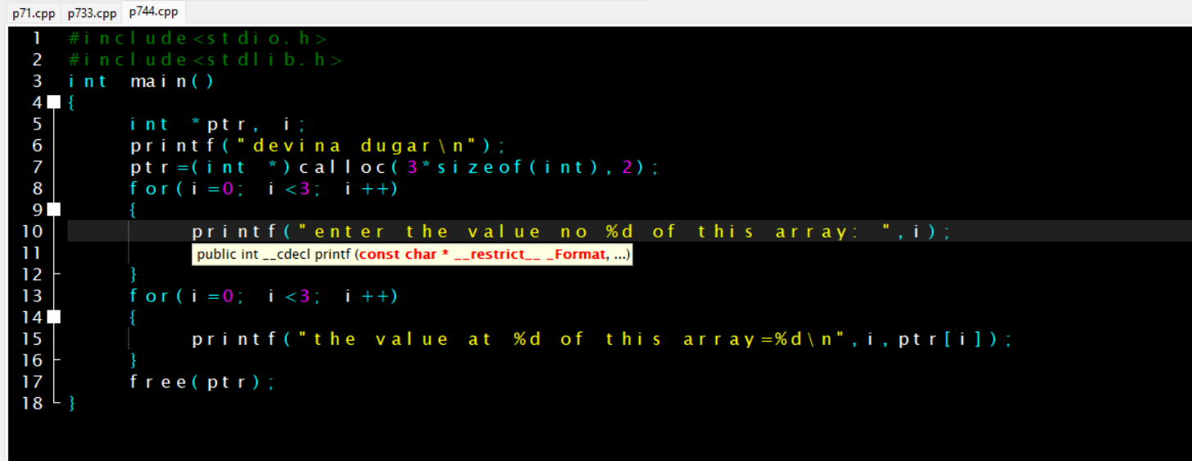

Output:

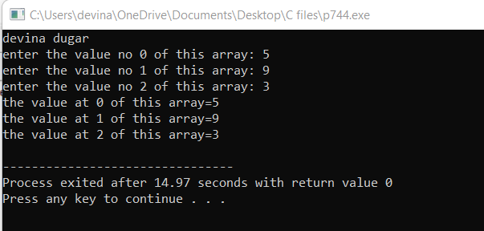

1. WAP to read an array and print the sum of all elements using dynamic memory allocation. (malloc)

Coding:

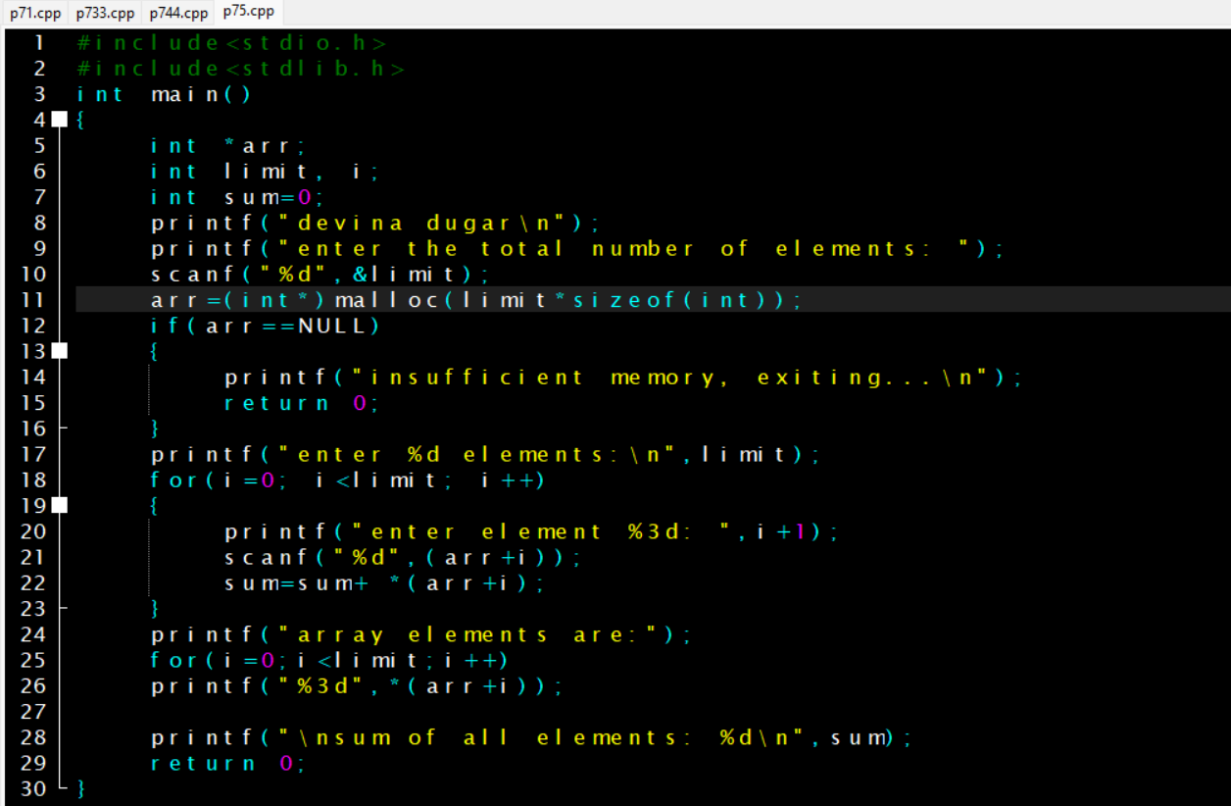

Output:

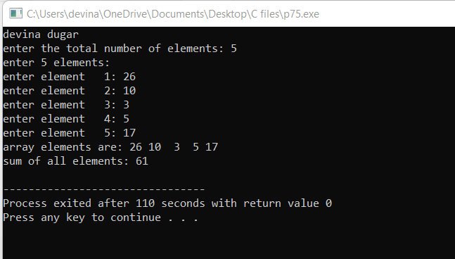

1. WAP to increase the size of allocated memory in a string using realloc.

Coding:

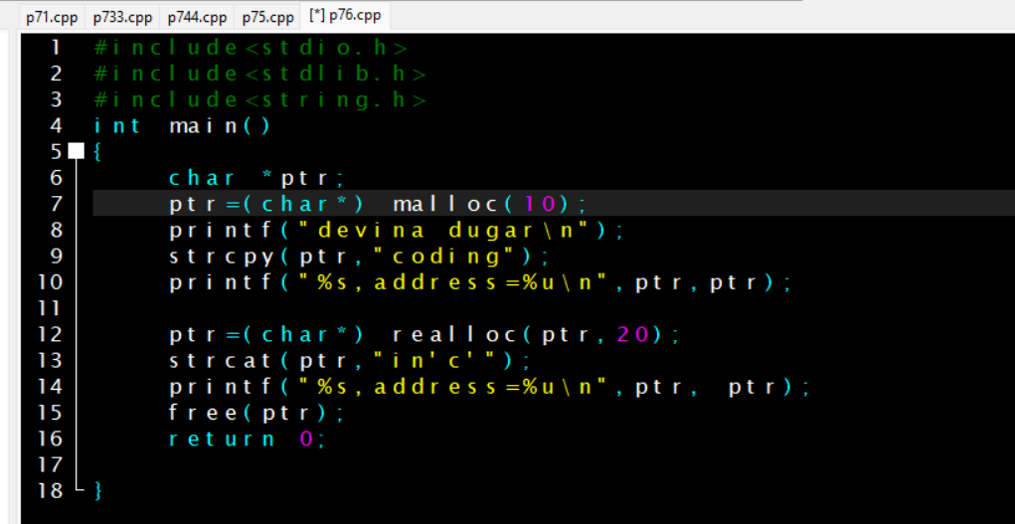

Output:

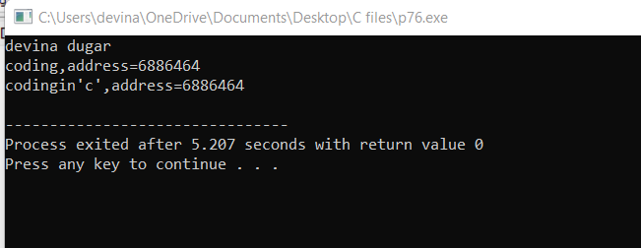

1. WAP to print the sum of two numbers using extern function.

Coding:

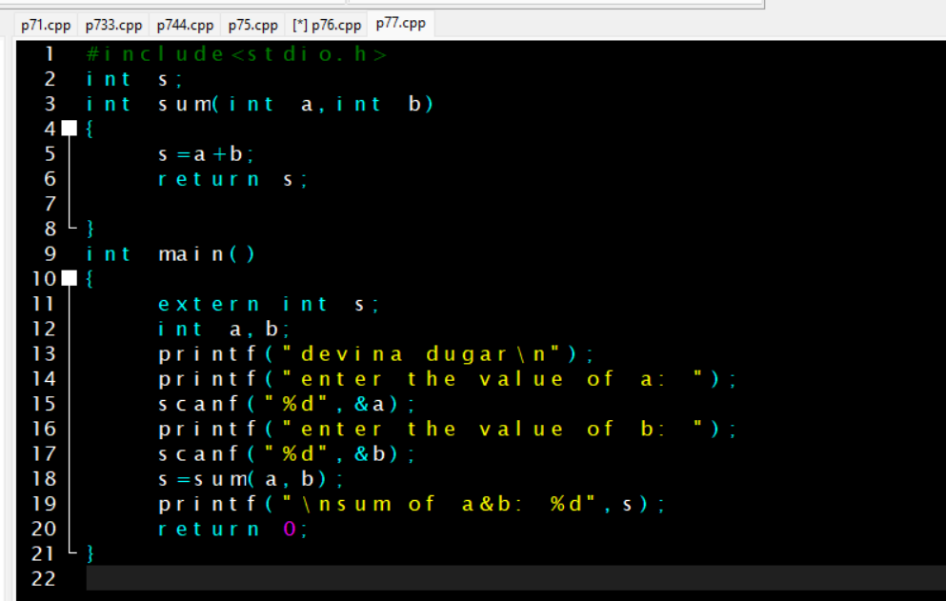

Output:

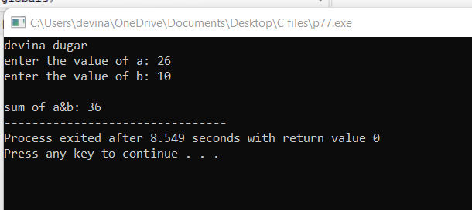

1. Write a program to perform some string functions.

Coding:

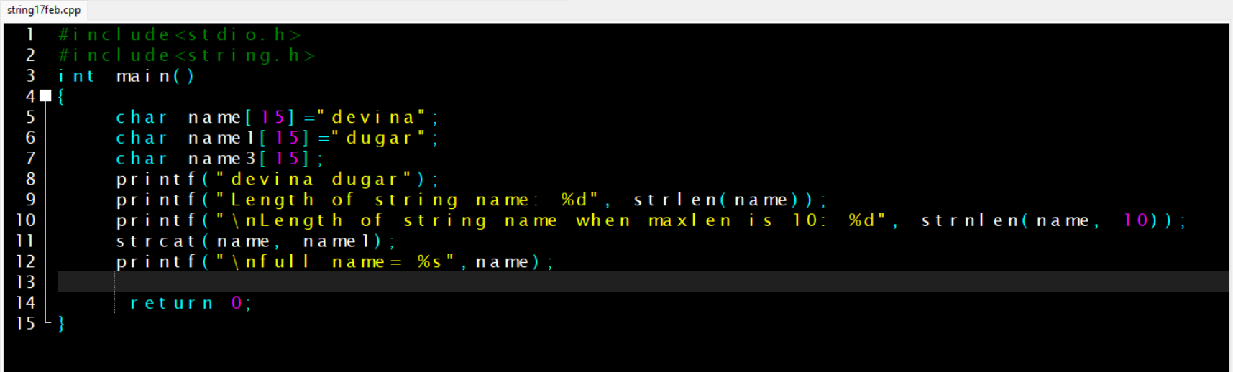

Output:

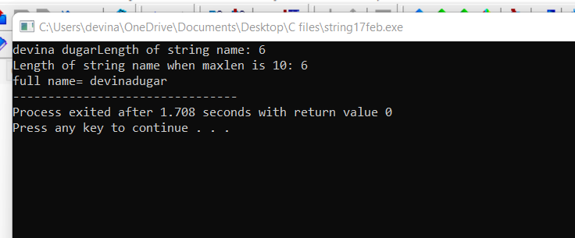

1. Write a program to find the largest of two numbers using macros.

Coding:

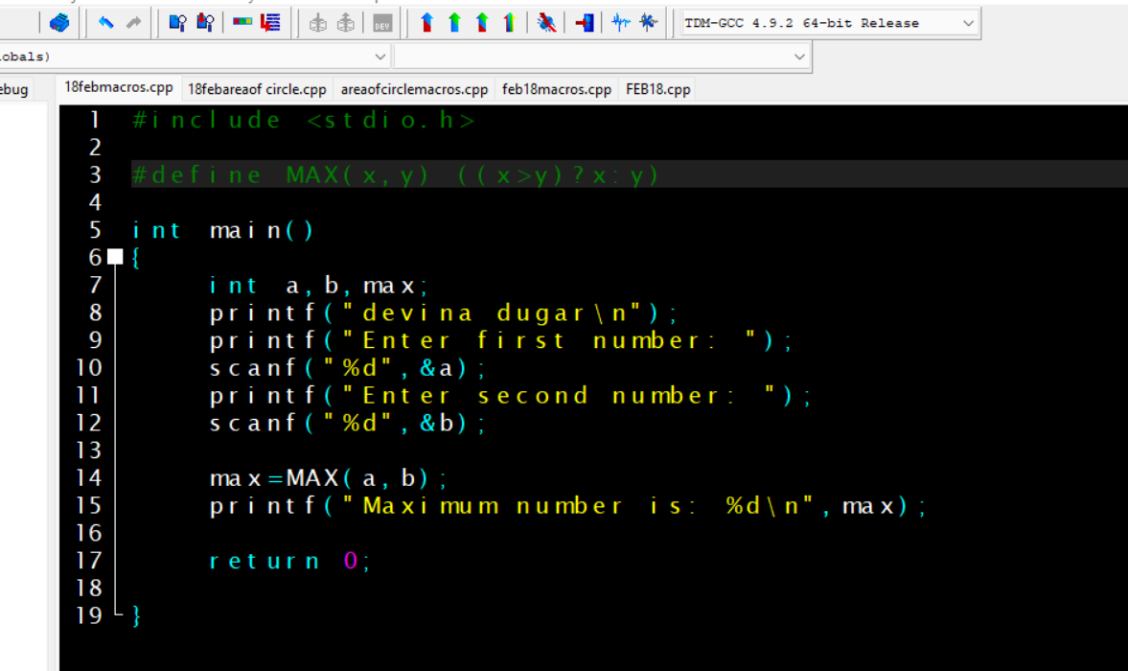

Output:

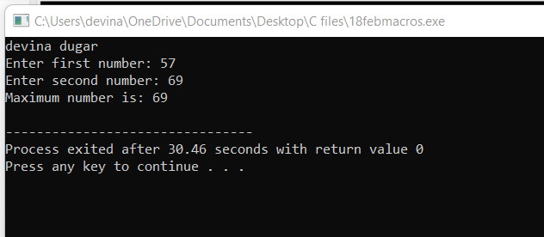

1. Write a program to calculate area of circle.

Coding:

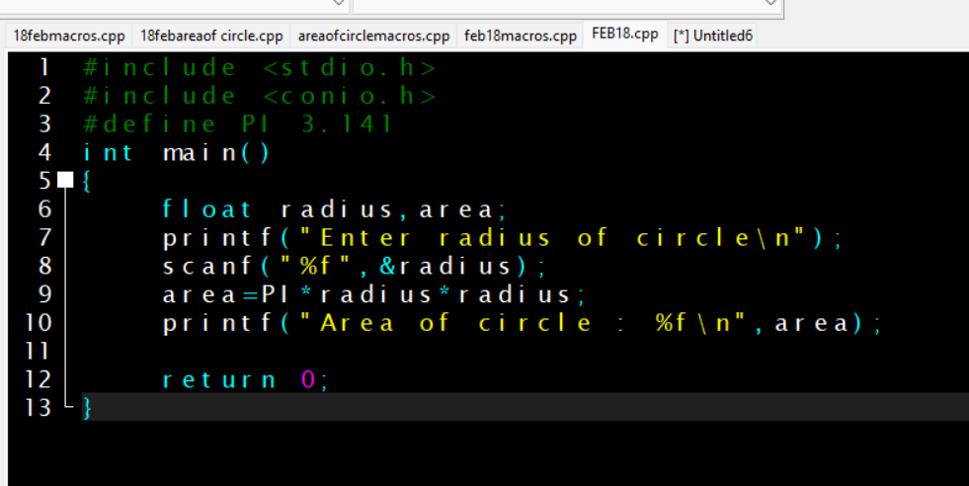

Output:

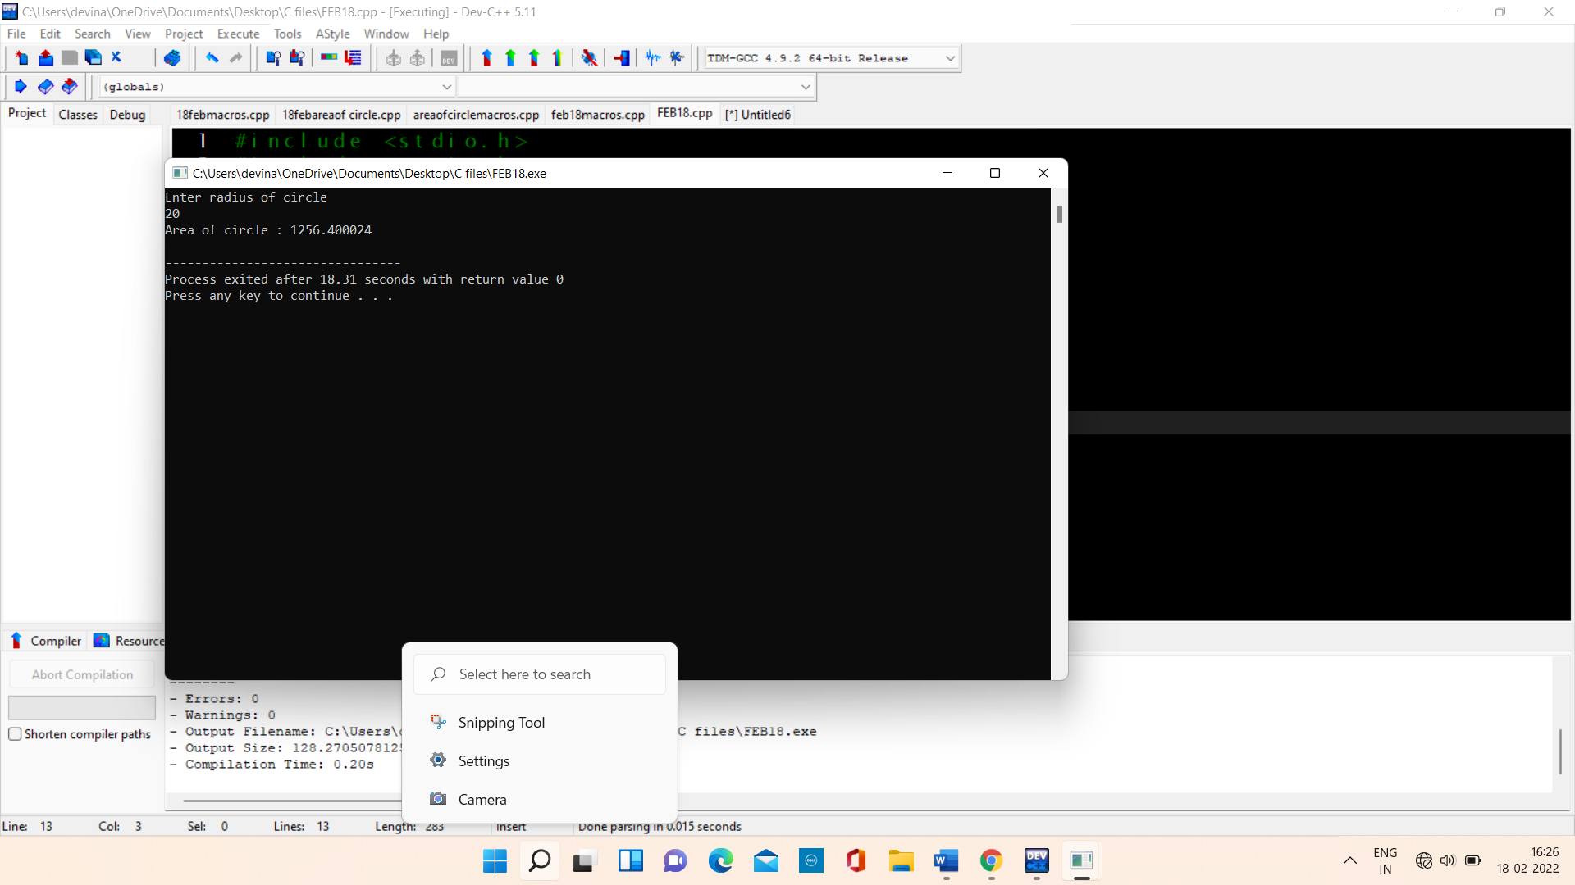

1. Write a program to identify whether the entered character is letter or digit and capital and small using pre defined macros.

Coding:

Output: